Set : Friday 14th Jan
Homework due in by: Wednesday 19th Jan (Eng for Mon 17th Jan!)
Next week:
- We will be continuing our work on deserts in Geography.
- We will be creating our own Art work in the style of Hokusai
- In Maths we are dividing decimals

This week…
- We have started reading ‘Kensuke’s Kingdom’ in English
- We have begun our Badminton sessions in P.E
- Maths this week has focussed on revision of multiplying/ dividing decimals We then multiplied decimals.

Reading:
It is also important that you read frequently throughout the week- at least three times. Please record in your reading record.

Spellings: Spring 1 Wk 3 Tested 21st Jan ‘our’ words
At least half a page in your homework books please!

*IDL children- please do at least 15 minutes of IDL practise – English and Maths! *

Maths - https://www.mathsisfun.com/decimals.html - Decimals revision- complete the quiz at the bottom of the page- record your score in your homework book!

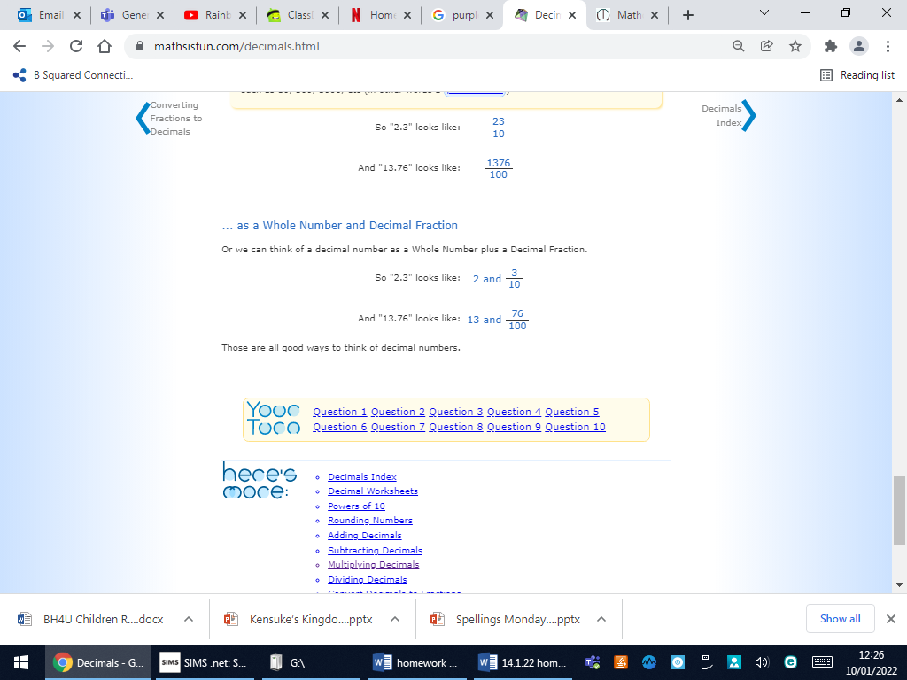
English- Read or listen to Chapter 4 of Kensuke’s Kingdom by Monday 17th! Jot down the main events in this chapter in order:
https://www.youtube.com/watch?v=FtCBmU8n-8w
file:///C:/Users/teacher/Downloads/Kensukes%20Kingdom%20Chapter%204.pdf
Main events in Chapter 4:

Set : Fri 26th Nov
Homework due in by: Wednesday 1st Dec
This week…We have finished reading ‘The Blurred man’
- In RE we have started looking at Advent
- In Maths we have found fractions of amounts and multiplied fractions
- We had our Christmas craft afternoon

Next week:
Assessment week- Weds- Friday
Advanced warning: Christmas Celebration- school hall 9- 9.30 am. 2 adults per child welcome -surname A-L Christmas Celebration- school hall 2.15- 2.45 -surname M-Z
Please email me to say if you are coming and how many seats you need. Thank you.

At Home… please learn your words for our Christmas celebration!

Reading:
It is also important that you read frequently throughout the week- at least three times. Please record in your reading record.

Spellings: Week 5 Children should practise the following spellings in their homework book- Autumn 2 Wk 5 Year 6 Bronze spelling passport words

*IDL children- please do at least 15 minutes of IDL practise – English and Maths! *

SPAG revision: Expanded noun phrases- watch the clip first:

https://www.bbc.co.uk/bitesize/topics/zwwp8mn/articles/z3nfw6f

Then complete the test on SPAG.com

Determiners: Watch the clip! https://www.youtube.com/watch?v=B8MnOXgX0Kk

Complete the sheet in your book.

Maths- Times Table rockstar practise- 15 mins please!

