Set :Friday14th Jan
Homework due in by: Wednesday 19th Jan (Eng for Mon 17th Jan!)
This week…
- We have started reading ‘Kensuke’s Kingdom’ in English
- We have begun our Badminton sessions in P.E
- Maths this week has focussed on revision of multiplying/ dividing decimals We then multiplied decimals.

Next week:
- We will be continuing our work on deserts in Geography.
- We will be creating our own Art work in the style of Hokusai
- In Maths we are dividing decimals

Reading:

It is also important that you read frequently throughout the week- at least three times. Please record in your reading record.

Spellings: Spring 1 Wk 3 Tested 21st Jan ‘our’ words
At least half a page in your homework books please!

*IDL children- please do at least 15 minutes of IDL practise – English and Maths! *

Maths - https://www.mathsisfun.com/decimals.html - Decimals revision- complete the quiz at the bottom of the page- record your score in your homework book!

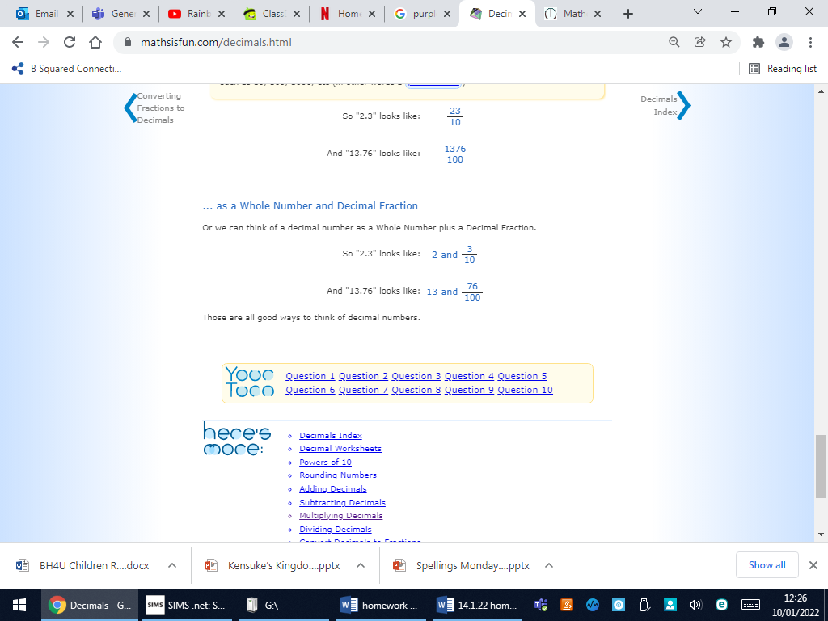

English- Read or listen to Chapter 4 of Kensuke’s Kingdom by Monday 17th! Jot down the main events in this chapter in order:
https://www.youtube.com/watch?v=FtCBmU8n-8w
file:///C:/Users/teacher/Downloads/Kensukes%20Kingdom%20Chapter%204.pdf
Main events in Chapter 4:

