Set : Fri 28th Jan Homework due in by: Wednesday 2nd Feb
This week…
- We have completed our work on Kensuke’s Kingdom.
- We have continued to enjoy golf lessons in P.E
- We have been revising fractions, decimals and percentages in maths.
Next week: We will be having a visit from Rev. Marie- anne to tell us about the Eucharist.
The History ambassadors will be going on their local trip on Monday 31st
- We will be starting a new English unit looking at Balanced arguments

Reading:
It is also important that you read frequently throughout the week- at least three times. Please record in your reading record.

Spellings: Week 5- ‘ible and able’ suffix patterns
*IDL children- please do at least 15 minutes of IDL practise – English and Maths! *

Grammar hammer 2- please complete
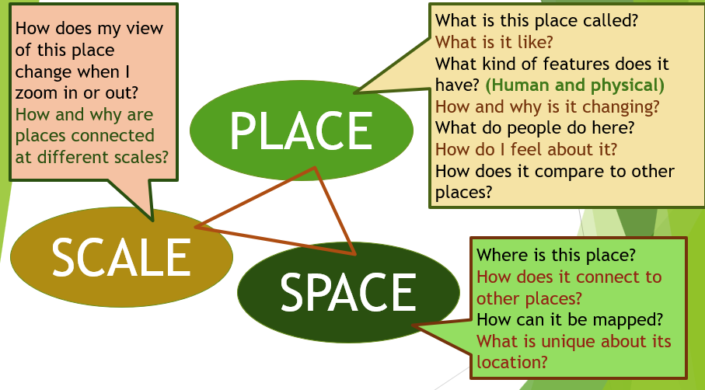
Geography – On paper design an eye-catching poster to explain what Geography is.
Good = Include the 3 key geography words (space, place and scale) as well as the word Geography – and add relevant images
Very good = AND includes – human and physical – fieldwork
Excellent = AND explains why we study it /why is it important
You can do this by hand or use a computer – whatever you do – use the space well and check your spelling!

Set : Fri 28th Jan Homework due in by: Wednesday 2nd Feb
This week…We have completed our work on Kensuke’s Kingdom.
- We have continued to enjoy golf lessons in P.E
- We have been revising fractions, decimals and percentages in maths.

Next week: We will be having a visit from Rev. Marie- anne to tell us about the Eucharist.
The History ambassadors will be going on their local trip on Monday 31st
- We will be starting a new English unit looking at Balanced arguments

Reading:
It is also important that you read frequently throughout the week- at least three times. Please record in your reading record.

Spellings: Week 5- ‘ible and able’ suffix patterns
*IDL children- please do at least 15 minutes of IDL practise – English and Maths! *

English- Grammar hammer 2- please complete

Geography – On paper design an eye-catching poster to explain what Geography is.
Good = Include the 3 key geography words (space, place and scale) as well as the word Geography – and add relevant images
Very good = AND includes – human and physical – fieldwork
Excellent = AND explains why we study it /why is it important
You can do this by hand or use a computer – whatever you do – use the space well and check your spelling!

