Tuesday afternoon 12.10.21

Geography – about half an hour on this -Should we protect the rainforest in Brazil? – a balanced argument - read this wagoll to remind you what we will be trying to write next week
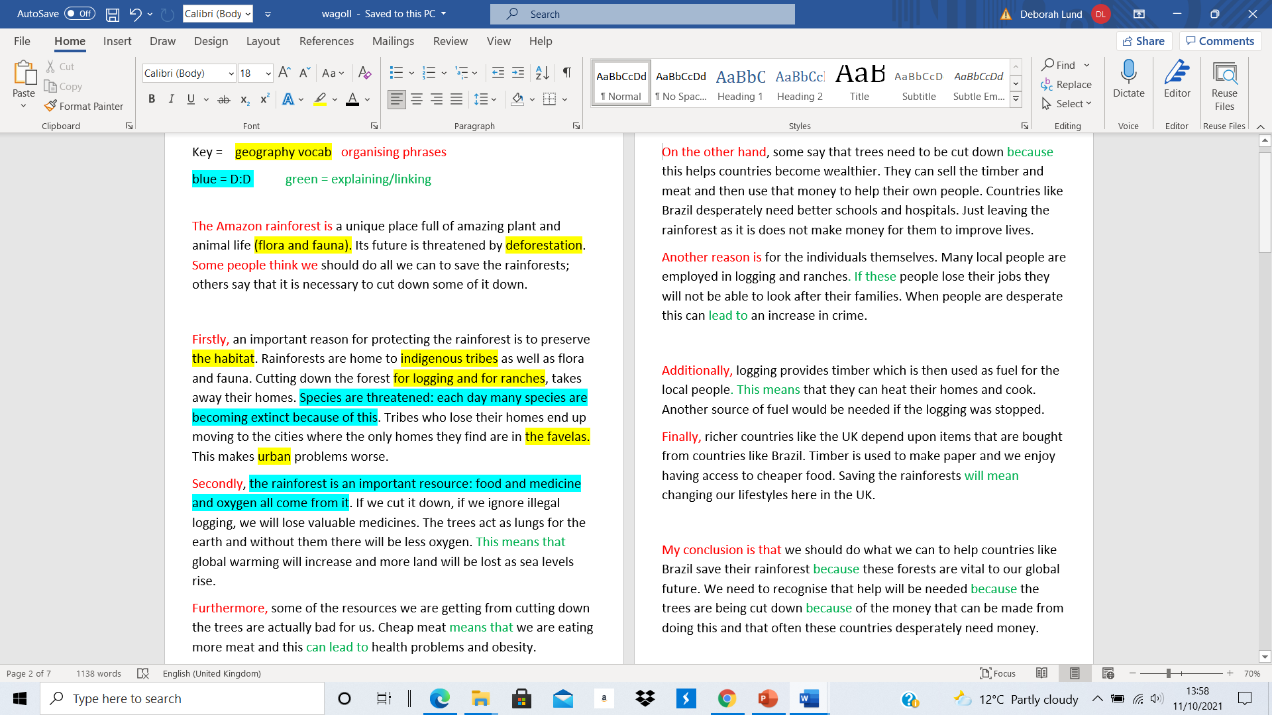

Use the instructions below and the word bank to make a bullet point list of what you want to write in answer to the question – Should we protect the rainforests of Brazil? – remember that you have to use your own words to write reasons for and against this idea – this video link will help. Try to include at least 8 of the words from the word bank
https://www.bbc.co.uk/bitesize/clips/zfp34wx
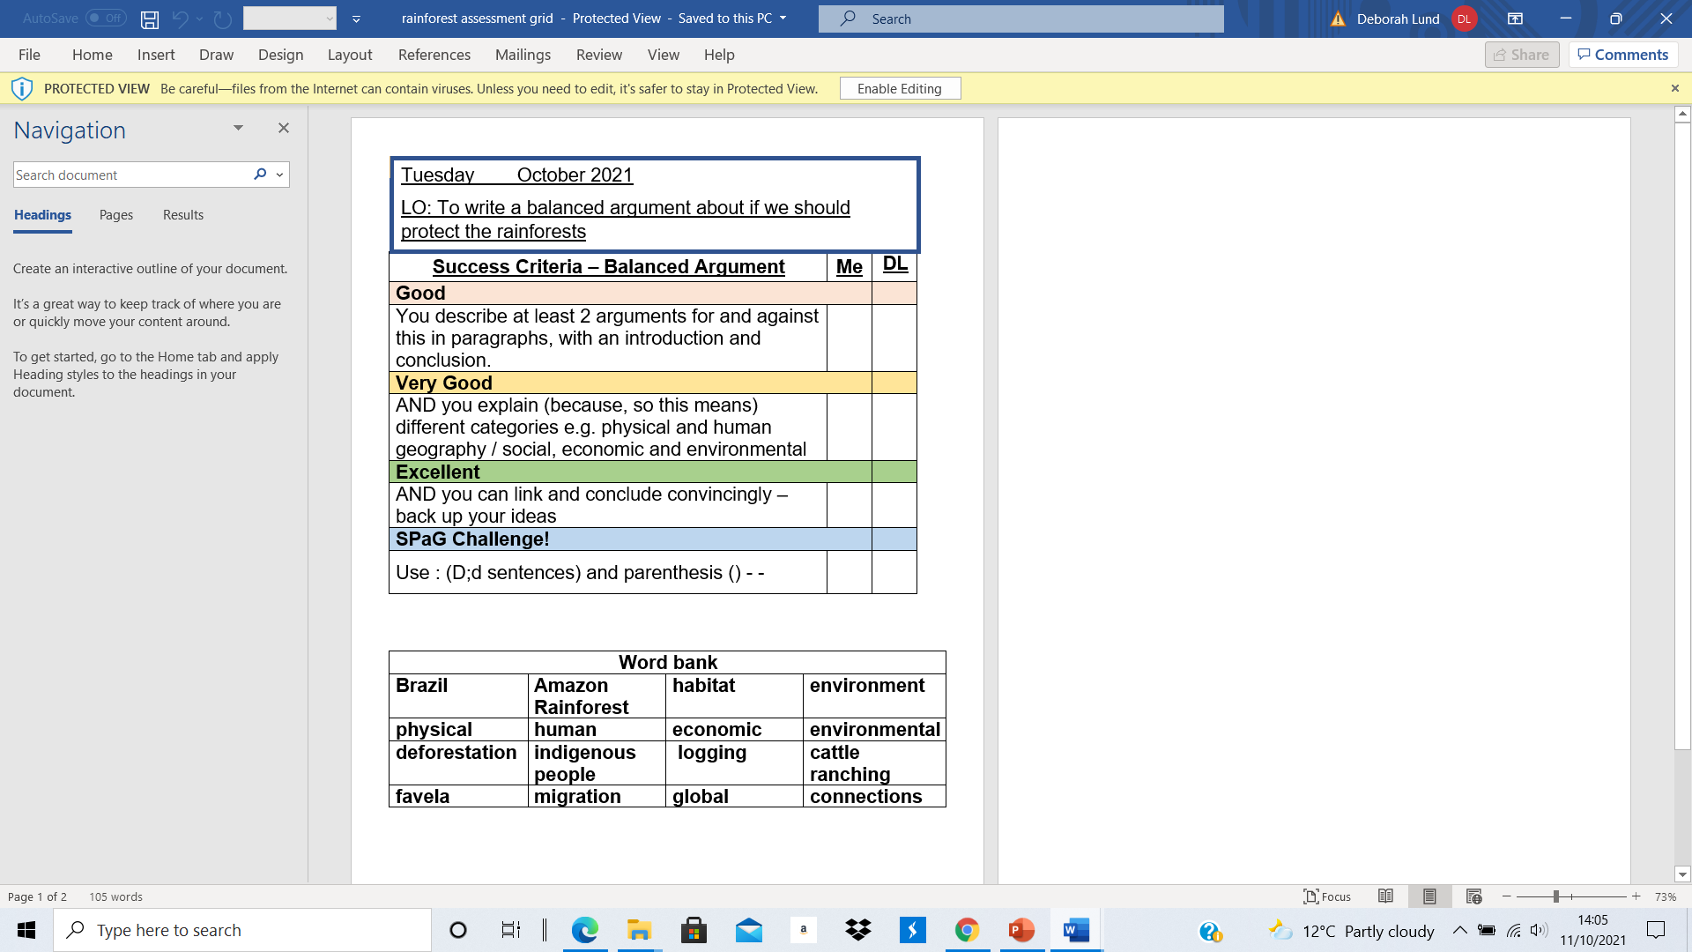

Black History Month – about half an hour on this
Do you wonder why we have why do we have Black History Month? – it’s a bit like someone forgetting your birthday for years and years – you’d then expect a special treat to make up for all the years missed. For many years, Black History wasn’t really taught in schools – so this is to make up for that.
Do you remember what you did last year on this? Use the link below to re watch the videos from last year. Harriet Tubman and Rosa Parks last year – what were these inspiring stories from history?
https://www.bbc.co.uk/teach/class-clips-video/history-ks2-true-stories/z72wpg8
Harriet Tubman = a woman born as a slave in the 1800s in the USA – who dared to runaway and then return to rescue lots of other slaves
Rosa Parks – about a century later, although slavery was now illegal in the USA, there was still lots of racism – segregation even – black and white people were kept separate in terms of schools and transport etc. One day Rosa Park refused to move from her seat when white people wanted it on a bus. It was the start of a campaign along with people like MLK – the Civil Rights movement – that led to the end of this system in the USA.
These are 2 inspiring women who did not just put up with the unfair way things were – they were brave enough to change things.
Today we are going to watch two short videos (about 3 mins each) about people whose families came from the Caribbean and Africa - some around 70 years ago or so - to work in this country. Maybe use googlemaps and see where the Caribbean is – North of Brazil – a 9 hour flights SW of the UK. A 3 week boat journey – not a cruise either!!
In those days the distance seemed much greater, as few people travelled by plane and few people had TVs and there were no computers and mobile phones!!! – so people did not really know as much as they do now about places that are far away
Many of our parents weren’t born in Southport – this is the story of a woman who came from Barbados to Blackpool
https://www.bbc.co.uk/teach/class-clips-video/history-ks2-black-british-stories-alison-bennison/zs9cbqt
Recap what they’ve learned – how much we still rely on workers from other countries for our NHS and social care
This story is about a coal miner whose father came from Nigeria– what do they know of think a coal mine would be like – and why was coal important?
https://www.bbc.co.uk/teach/class-clips-video/history-ks2-black-british-stories-mac-williams/zng3f82
Recap – importance of coal in the past to fuel our factories and homes – mines were often in the North of England – deep underground and dangerous – ventilation avoided terrible explosions
Summarise = We are a migrant nation – always have been – Stone Age people travelled here from across Europe – Romans from Italy – Saxons from Germany – Vikings from Scandinavia – 1066 our last invasion – Normans from France – but since then people have come here to a place of safety or to work- from all over the world –

French lesson – about half an hour on this
Use this link to revise what we did last week – talking about what subjects you like and dislike

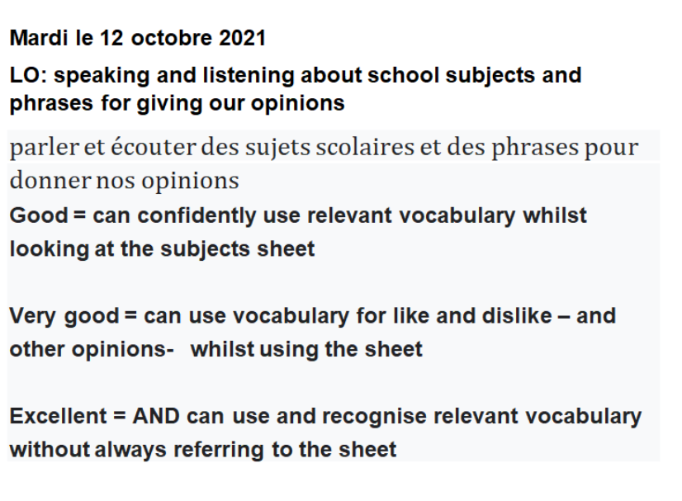
https://www.bbc.co.uk/bitesize/topics/zjcbrj6/articles/z4q8g7h

