Tuesday afternoon 19.10.21
Aim to do up to an hour of Geog – then French for about half an hour and finish with some Art display work on poppies –
Geography – Rainforest Assessment today – Question = a balanced argument for Should we protect the rainforests of Brazil?
Use the wagoll below and the instruction sheet with success criteria – You can had write or type you writing.
Wagoll here
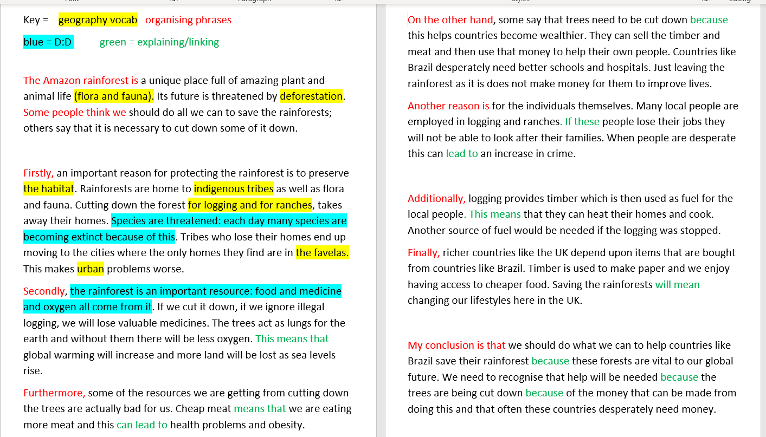
Instruction sheet is here
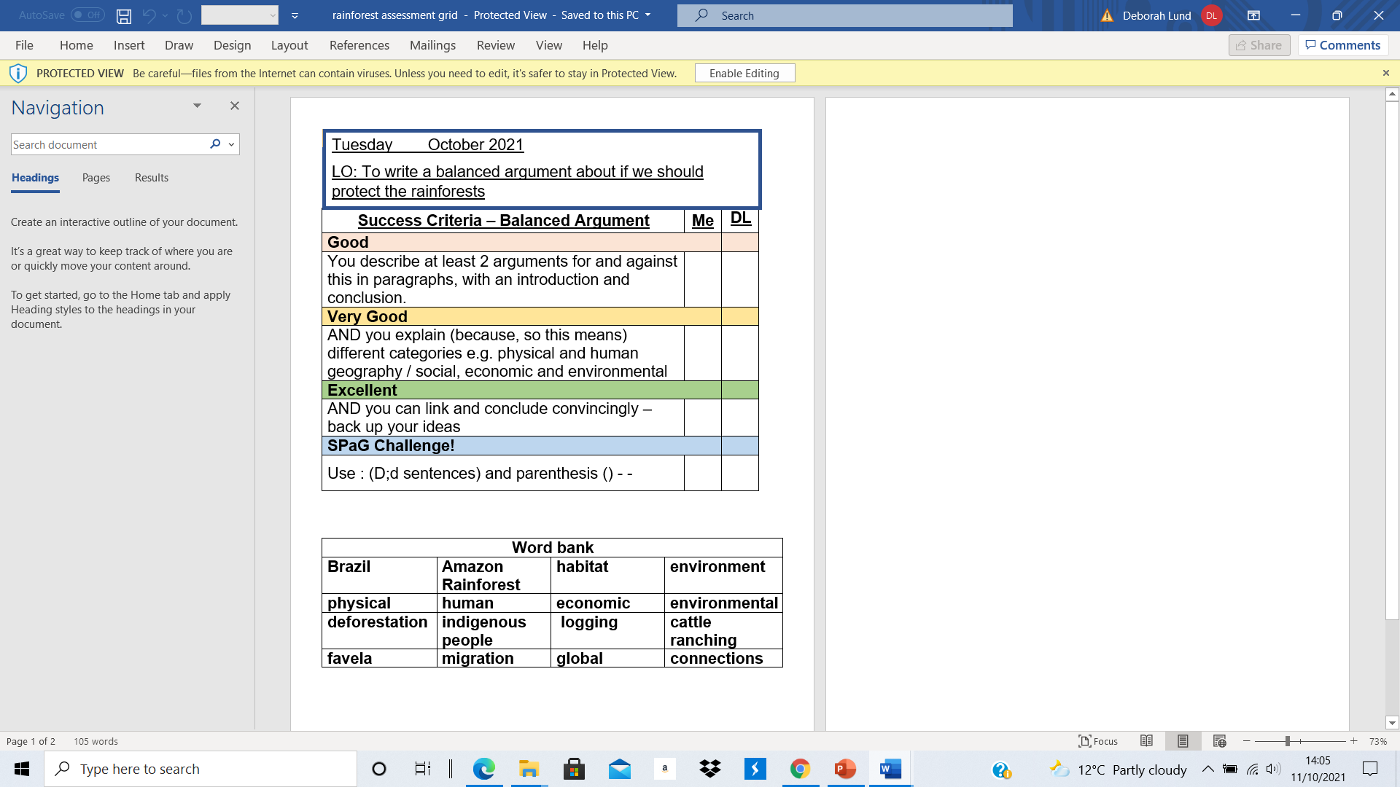
Take about 15 minutes to refresh your mind about what you are going to write about – Can you explain and plan to use at least 8 of the key words above?
Follow the timings below – and have the wagoll to look at from time to time -
Intro – 6 minutes – Only needs to be 2 or 3 sentences e.g.
- A sentence saying where in the world the Amazon rainforest of Brazil is e.g. which hemisphere or continent
- A sentence saying what is so special about it – maybe show off phrases like flora and fauna – use parenthesis
- A sentence explaining that it is under threat
Paragraphs about protecting it – 15 minutes for 3 short paragraphs – 5 mins on each -remember to pack in the key words from the grid – make sure WAGOLL is not out for all of this – put away after 5 mins or so? Spag challenge done ? D;d sentence or parenthesis?
Paragraphs about why people cut it down – 15 minutes for 3 short paragraphs – 5 mins each remember to pack in the key words from the grid – make sure WAGOLL is not out for all of this – put away after 5 mins or so? Spag challenge done ? D;d sentence or parenthesis?
Conclusion – 5 mins – look back at what you have written – show an understanding of the views you disagree with – remember that this country cut down its forests hundreds of years ago – it is what countries do when they start making money from factories instead of farming. Explain how our lives are connected to the rainforest – and what we can maybe do to help protect it rather than just saying countries like Brazil should.
FILL IN THE ME COLUMN OF THE ASSESSMENT GRID AND TICK ALL THE KEY WORDS USED

French for half an hour
The LO sheet is here with last week’s date– change the date please
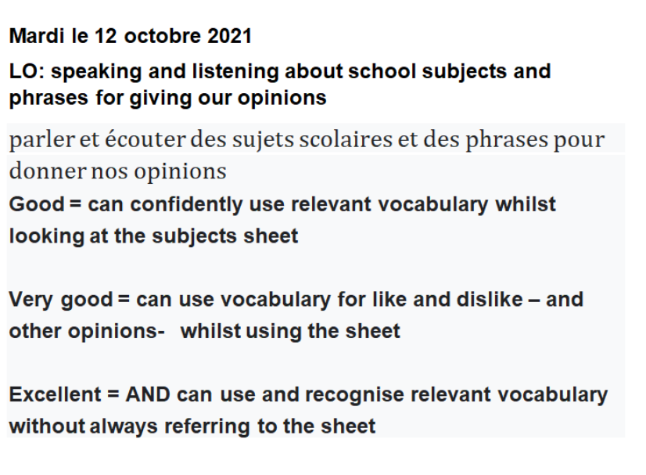
Use the website below to practice talking about school subjects – keep repeating phrases so that you become more confident – talk out loud and try to repeat without looking at the sheet or website
https://www.bbc.co.uk/bitesize/topics/zjcbrj6/articles/z4q8g7h
Last part of the afternoon – half an hour or so –
If you have bright colours - create really bright poppy images –A5 size – we will photocopy and enlarge the best – use the pictures here as inspiration –
If you only have dark colours – design a remembrance poster – use a phrase like We will remember them – OR Never forgotten – OR With grateful thanks



