Jubilee Bunting Home Task
In class we have investigated bunting – shapes and sizes and designs.
We have explored what would work best.
It can be drawings on paper, or collaged from recycled materials.
We are trying to avoid using single use plastic or buying anything that we don’t already have.
Each piece needs to be roughly 20cm in size if possible. Five pieces would be great.
Please send in when done so that we can start decorating our rooms!
Some traditional ideas are below but we’d love you to be more creative and think of using ideas from inventions or events from the last 70 years.
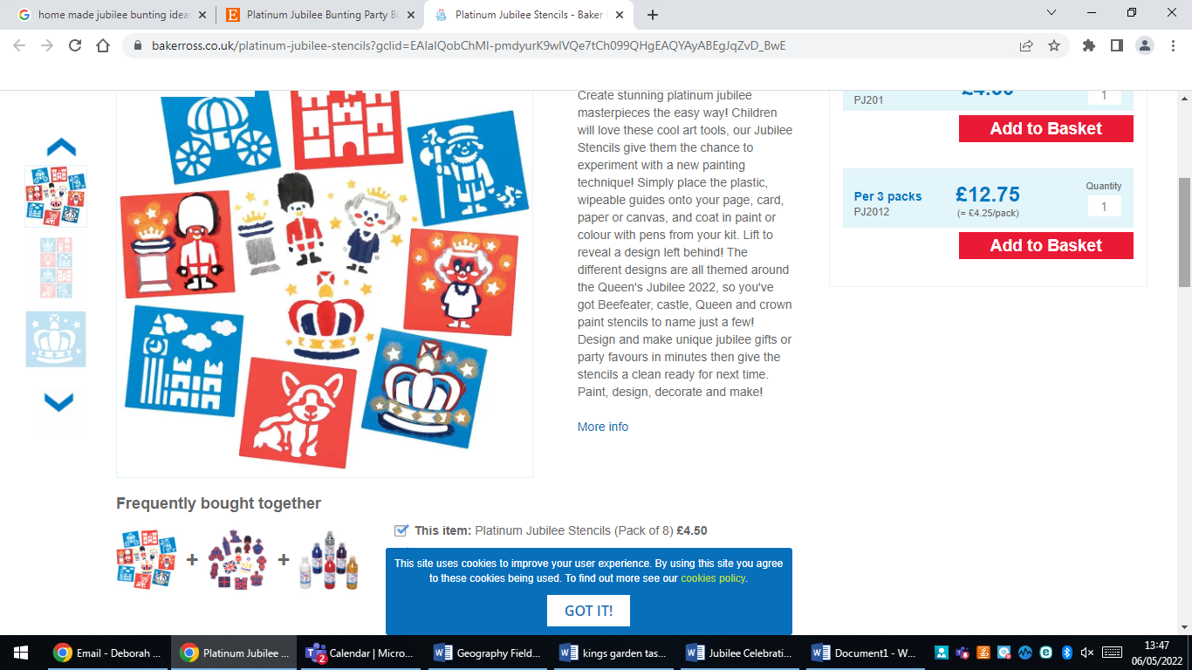
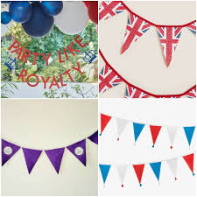
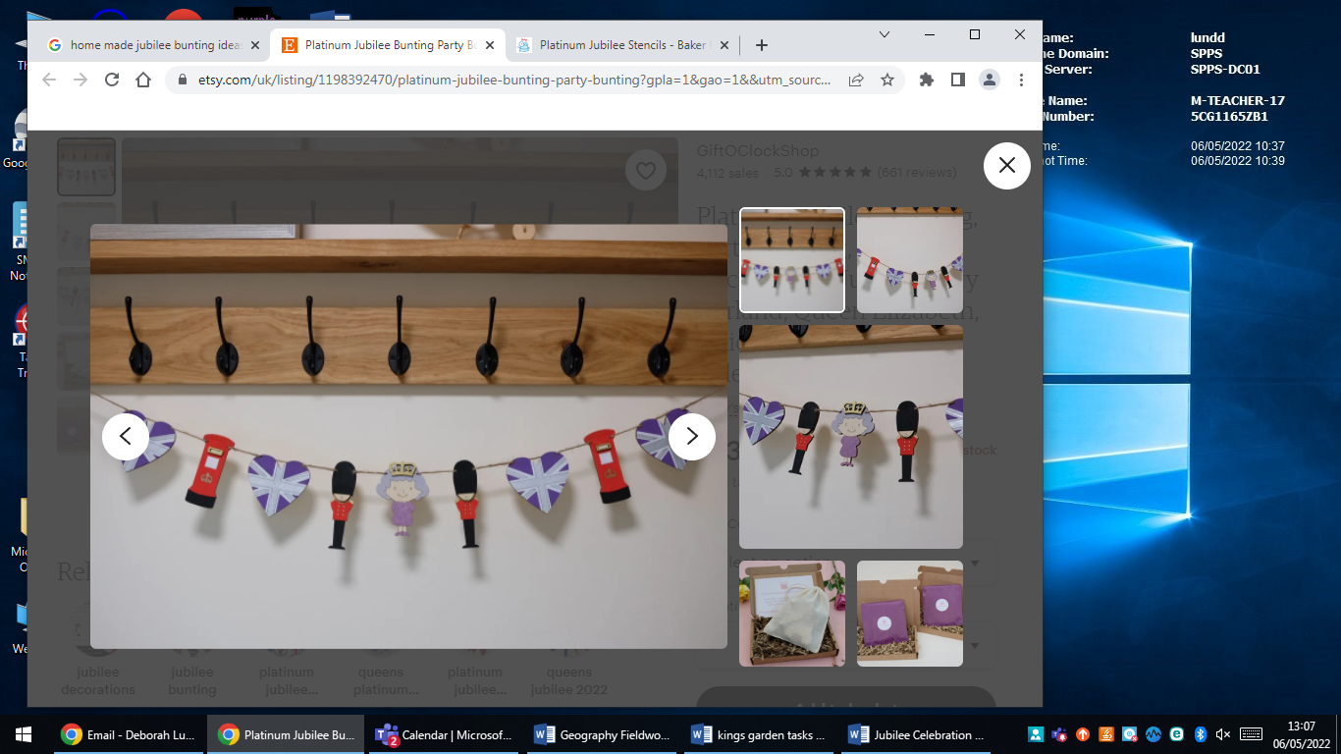

Jubilee Bunting Home Task
In class we have investigated bunting – shapes and sizes and designs.
We have explored what would work best.
It can be drawings on paper, or collaged from recycled materials.
We are trying to avoid using single use plastic or buying anything that we don’t already have.
Each piece needs to be roughly 20cm in size if possible. Five pieces would be great.
Please send in when done so that we can start decorating our rooms!
Some traditional ideas are below but we’d love you to be more creative and think of using ideas from inventions or events from the last 70 years.

