
Homework
My Year 4 Reading Journal
Reading scheme book I am reading ______________________________________
My Weekend entry for my school book or my own choice of reading book
Pages read:_________________________
What has happened in the book so far?
____________________________________________________________________________________________________________________________________________________________________________________________________________________________________________________________________________________________________________________________________________________________________________________________________________________________________________________
Rate your reading

Set Friday 10th September and due in by Weds 15th September
Reading- Complete your reading journal. Read to an adult & ask them to fill in your reading log please.
Spelling homework— learn the spellings given out in your Home Spelling Book to be tested on 17.09.21
Maths homework book- page 3 NBumber & place Value
Find out some facts about the artists;
Jean Metzinger
Claude Monet
Who’s work do you like best?
Why?

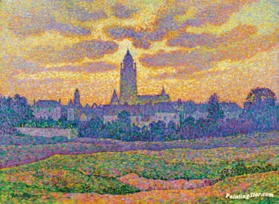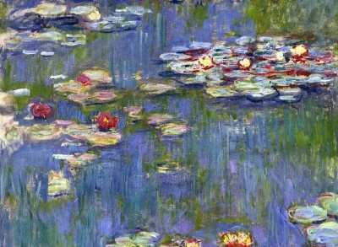

Parent signature: ___________________________________________________________________
Mrs Afford

