Week Ending: 8.9.23 Homework due: Tuesday 4th July 2023

This week…
Welcome to Year 4! I have been counting down the days since I saw you last. I have heard about so many amazing summers and I am really looking forward to a great year. This week was very much about establishing routines and we are raring to go with our first full week starting Monday. I look forward to all this year brings! If you have any questions or want to get in contact, email me on vernona@sps.sefton.school and I try my best to reply in working hours.
Mr Vernon
Next week…
- Tuesday – PE day
- Thursday - PE day – Swimming. Please wear normal PE kit and bring your swimming kit in a bag.

At Home… Reading:
My entry for my school book or my own choice of reading book.

The book I read: _______________________________
Pages read: _____________________

Adult’s score
Rate your reading
Tick if complete
Reading
- Each week, we ask for 3 reading entries into reading logs. We see massive benefits for those children spending 5 minutes reading aloud to an adult
https://www.youtube.com/watch?v=DR9FGjcG2TMz
https://www.youtube.com/watch?v=DR9FGjcG2TMz
TTRS
Score /25
- Log on at home and complete 1 Soundcheck
Science:
- In Science this term, we will be making classifcation keys. A head start in understanding these would be to DIG up your family tree! Go back as far as you can and follow the lines with accuracy.
https://www.youtube.com/watch?v=DR9FGjcG2TMz
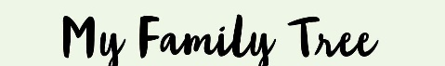
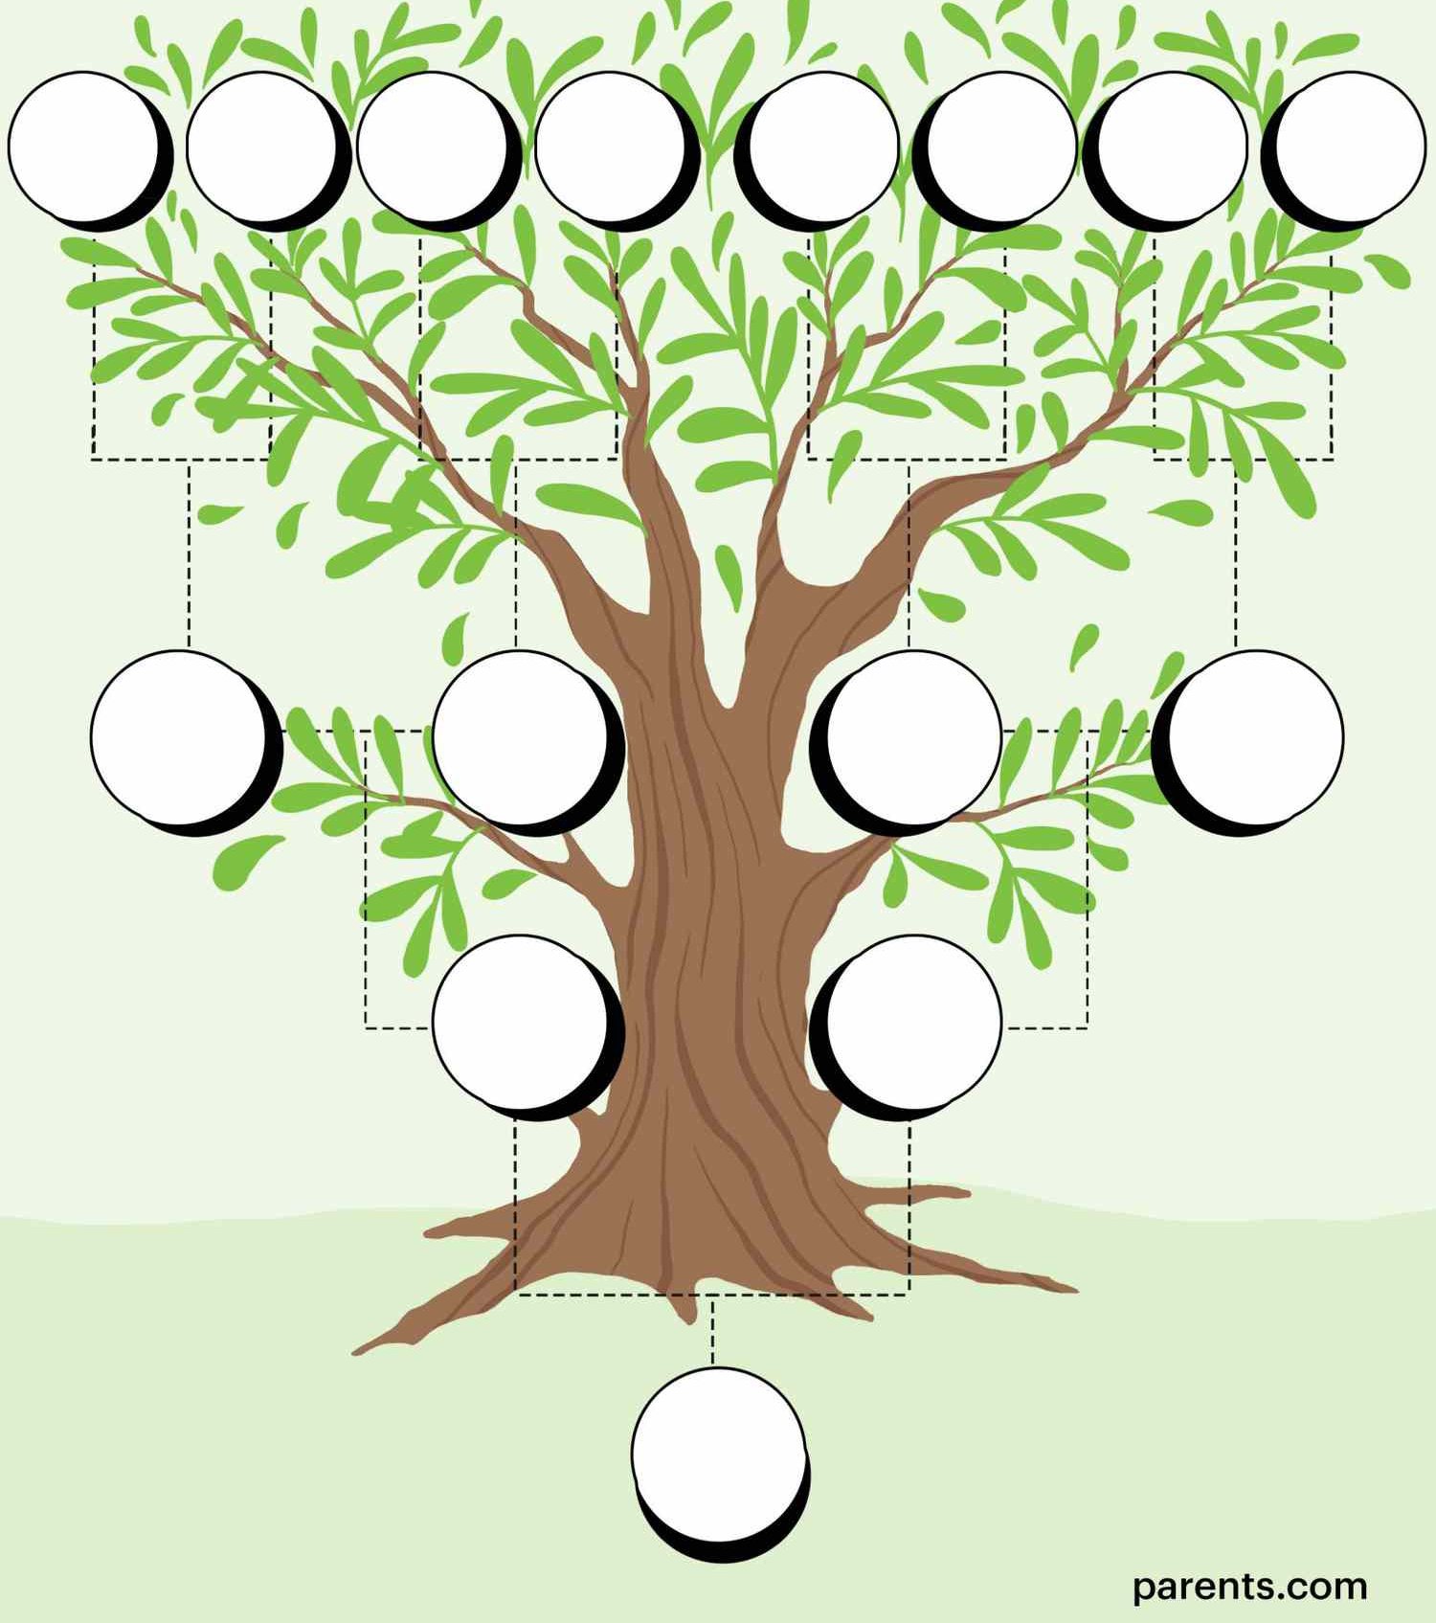

Please have an adult sign this homework page

If you have any comments, positive or otherwise, please write below

Missing homework will be completed Wednesday/Thursday lunchtimes.

Parent/Carer comments:

Adult Signature: ………………………………

