
Please draw and write about Pirates Love Underpants.
My Weekly Journal

_____________________________________________________________________________

Homework
Set Friday 12th July and due in by Wednesday 17th July.
Communication and language – Draw and write about Pirates Love Underpants.
Maths – Doubling dice activity.

Important information in relation to year 1 – All children have now met their new teachers ( Mrs Parsons and Miss Samuel ) ready for September. Please have lots of discussions around transitions. This is an exciting time for your child and nothing to be worried about. Your child will spend some time in their new classroom with their new Teachers on Thursday 18th July.

Please practice reading these words:
Our new Phase 5 sounds so far, please practice ready for assessing next week – ay, ou, ie, ea, oy, ir, ue, aw, wh, ph, ew, oe , au, ey . ‘c’ pronounced as ‘s’ in the words ‘mice’ ‘dice’.

Split digraphs – a-e and e-e , i-e , o-e , u-e, c (pronounced ‘s’ in the word mice, space).

Our new harder to read and spell words – oh, their, people, mr, mrs, your, ask, should, would, could, house, mouse, water, want, very

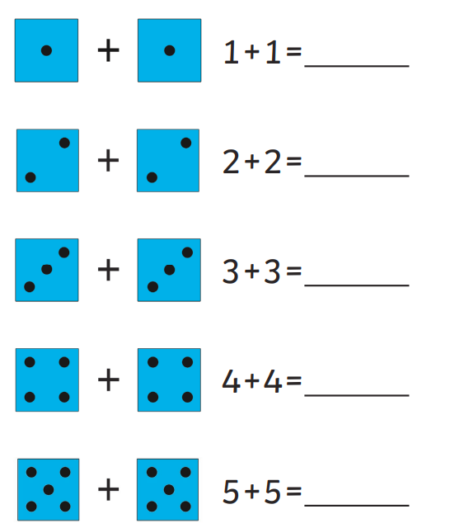

Thank you for your support

Parent signature: Miss Houghton

