
Please draw and write about your weekend.
My Weekly Journal

_____________________________________________________________________________

Homework
Set Friday 5th July and due in by Wednesday 10th July.
Communication and language – Draw and write about your weekend.
Literacy – Write the word to match the picture.
Maths – Numicon addition, something we need to practice ready for year 1.

Please practice reading these words:
Our new Phase 5 sounds so far, please practice ready for assessing next week – ay, ou, ie, ea, oy, ir, ue, aw, wh, ph, ew, oe , au, ey . ‘c’ pronounced as ‘s’ in the words ‘mice’ ‘dice’.

Split digraphs – a-e and e-e , i-e , o-e , u-e

Our new harder to read and spell words – oh, their, people, mr, mrs, your, ask, should, would, could, house, mouse, water
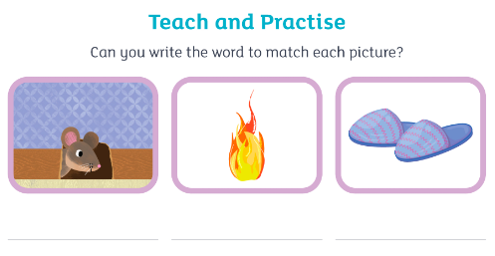

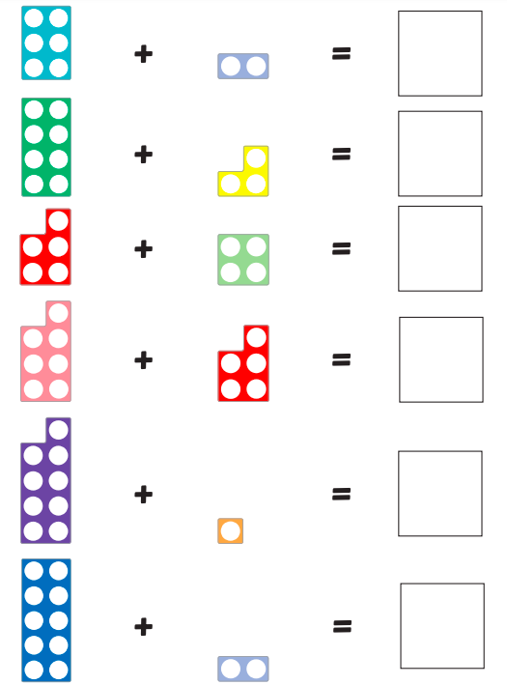

Thank you for your support

Parent signature: Miss Houghton

