
Please draw and write about sharing a shell.
My Weekly Journal

_____________________________________________________________________________

Homework
Set Friday 28th June and due in by Wednesday 3rd July.
Communication and language – Draw and write about sharing a shell.
Literacy – Write the word to match the picture.
Maths – choose a story and draw a map of the route the character takes.

Please practice reading these words:
daze
chair
popcorn
container
pause
chimney
rake
delete

Our new Phase 5 sounds so far, please practice – ay, ou, ie, ea, oy, ir, ue, aw, wh, ph, ew, oe , au, ey

Split digraphs – a-e and e-e

Our new harder to read and spell words – oh, their, people, mr, mrs, your, ask, should, would, could

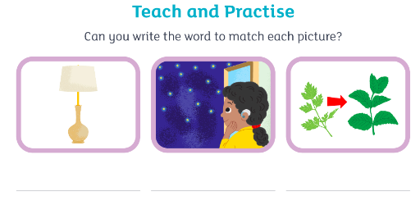

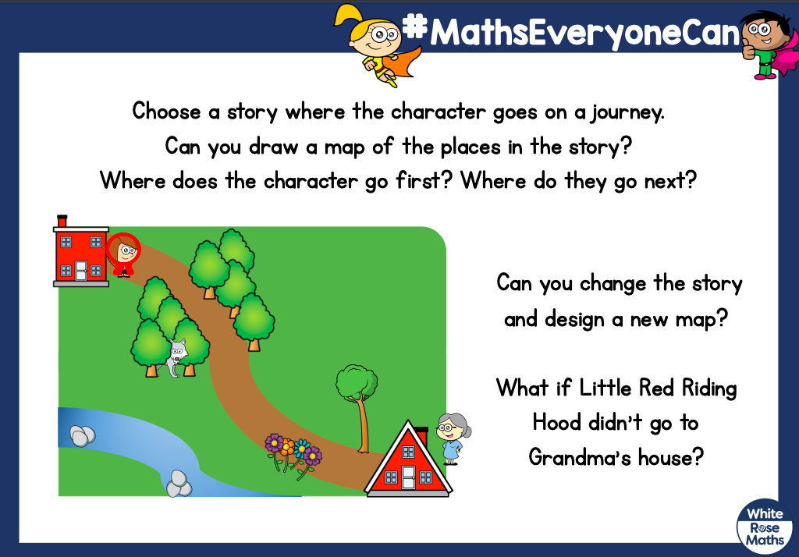

Thank you for your support

Parent signature: Miss Houghton

