
Please draw and write about your weekend.
My Weekly Journal

_____________________________________________________________________________

Homework
Set Friday 21st June and due in by Wednesday 26th June.
Communication and language – Draw and write about your weekend.
Literacy – Write the word to match the picture.
Maths – repeating patterns activity, you can finger paint or colour !

Please practice reading these words:
spoon
cobweb
night
gaze
wheel
wheat
whisper
whip

Our new Phase 5 sounds so far, please practice – ay, ou, ie, ea, oy, ir, ue, aw, wh, ph, ew, oe

Our new harder to read and spell words – oh, their, people, mr, mrs, your, ask, should

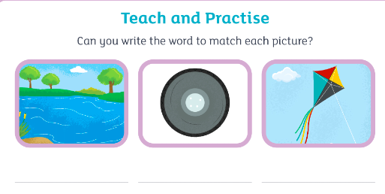
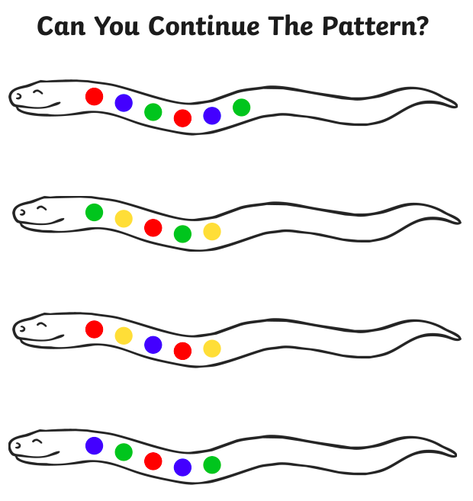

Thank you for your support

Parent signature: Miss Houghton

