
Please draw and write about Starry Eyed Stan.
My Weekly Journal

_____________________________________________________________________________

Homework
Set Friday 14th June and due in by Wednesday 19th June.
Communication and language – Draw and write about Starry Eyed Stan.
Literacy – Write the word to match the picture.
Maths –Colour by addition to 10 activity.

Please practice reading these words:
mug
hat
clap
shout
fish
chin
splash
spray

Our new Phase 5 sounds so far, please practice – ay, ou, ie, ea, oy, ir, ue, aw

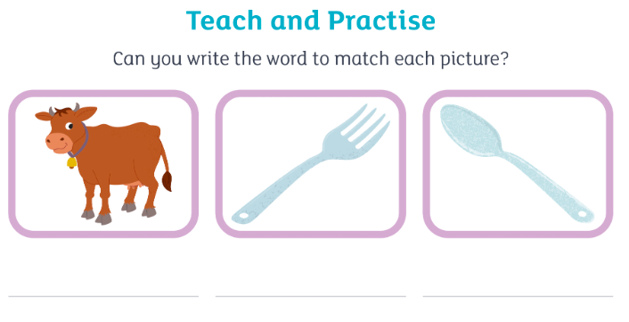

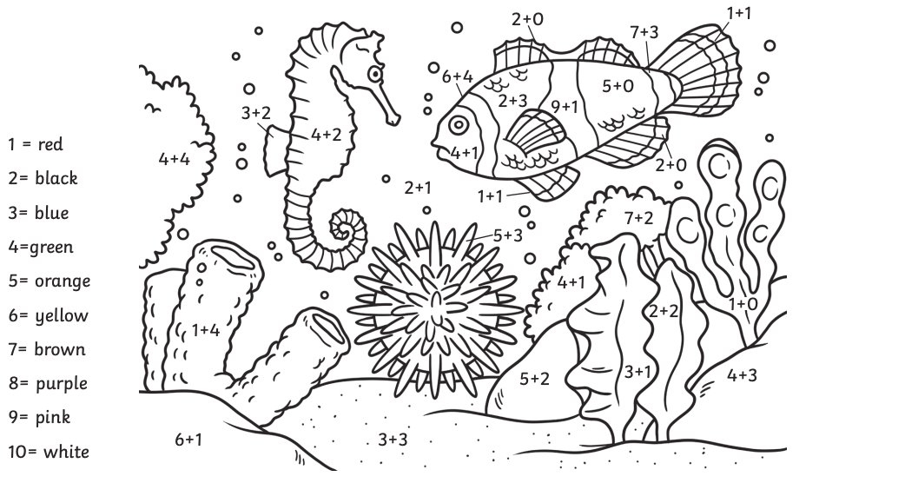

Thank you for your support

Parent signature: Miss Houghton

