
Please draw and write about Your half Term Break .
My Weekly Journal

_____________________________________________________________________________

Homework
Set Friday 7th June and due in by Wednesday 12th June
Communication and language – Draw and write about your half term break.
Literacy – Write the word to match the picture.
Maths – Sharing teddy bears picnic activity.
Take a picture or create a drawing of your teddy bears picnic.

Please practice reading these words:
sloth
blink
played
stay
tried
dries
dreaming
sound

Our new Phase 5 sounds this week, please practice – ay, ou, ie, ea

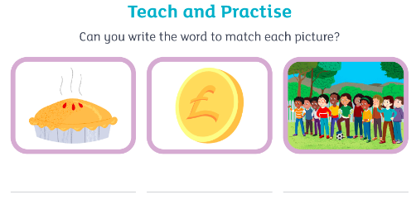

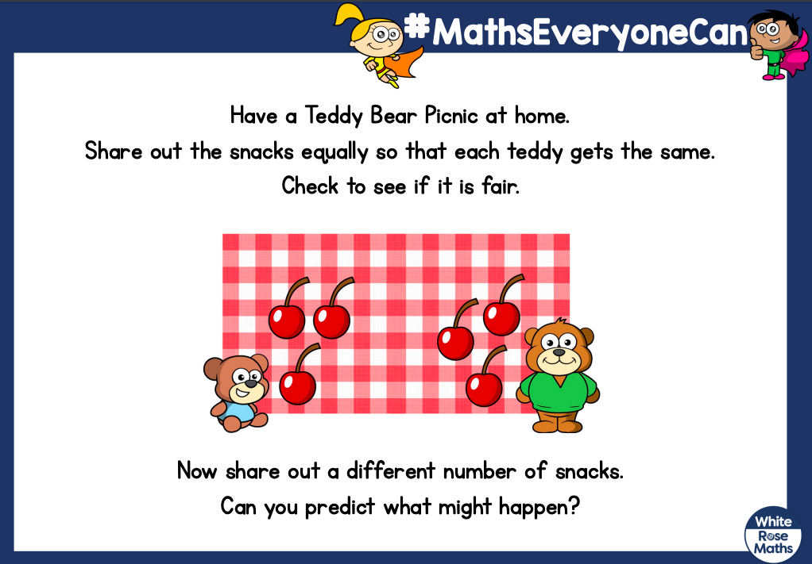

Thank you for your support

Parent signature: Miss Houghton

