
Please draw and write about The Three Little Pigs.
My Weekly Journal

_____________________________________________________________________________

Homework
Set Thursday 23rd May and due in by Wednesday 5th June
Communication and language – Draw and write The Three Little Pigs.
Literacy – Write the word to match the picture.
Maths – Sharing / grouping activity.
Please also practice your number formation on the next page.

Please practice reading these words:
flight
cloak
quack
higher
speak
Monday
Tuesday
Wednesday
Thursday
Friday
Saturday
Sunday

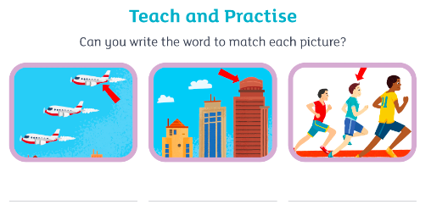
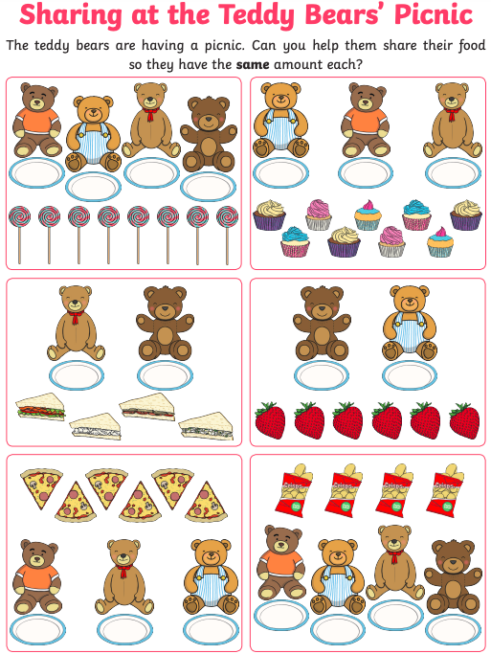

Thank you for your support

Parent signature: Miss Houghton

