
Please draw and write about your weekend.
My Weekly Journal

_____________________________________________________________________________

Homework
Set Friday 17th May and due in by Wednesday 22nd May.
Communication and language – Draw and write about your weekend.
Literacy – Write the word to match the picture.
Maths – Grandpas quilt shape design task – complete on separate piece of paper.

Please practice reading these words:
skin
green
stood
first
drift
habit
modern
rooftop

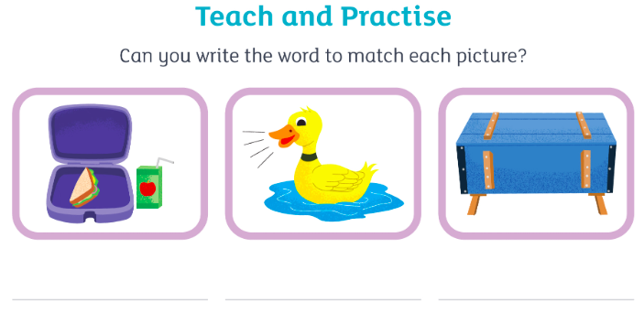

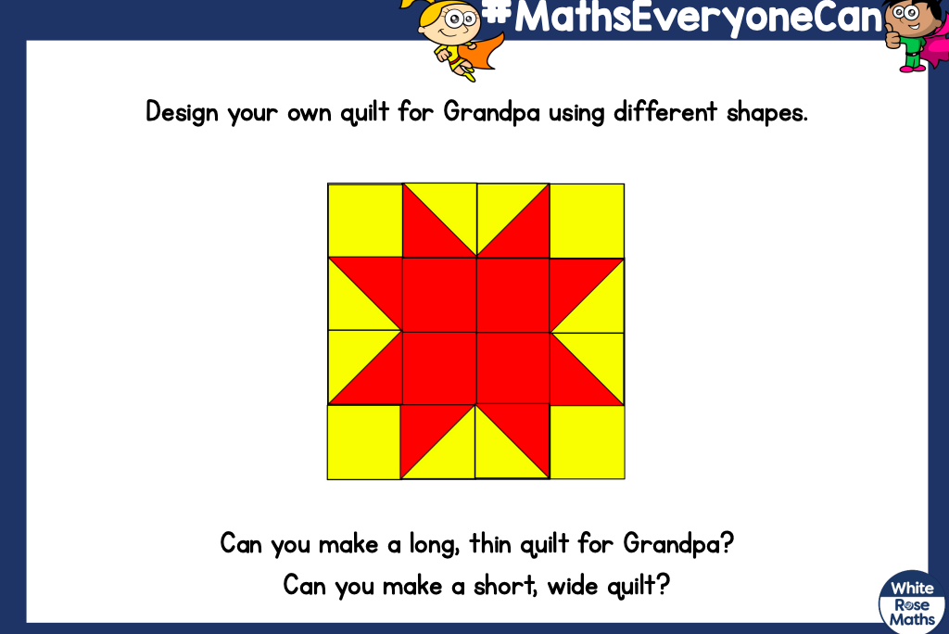
Thank you for your support

Parent signature: Miss Houghton

