
Please draw and write about your weekend.
My Weekly Journal

_____________________________________________________________________________

Homework
Set Friday 10th May and due in by Wednesday 15th May.
Communication and language – Draw and write about your weekend.
Literacy – Write the word to match the picture.
Maths – simple subtraction worksheet.

A friendly reminder : Now that we are in the summer term, we are getting your child prepared for Year 1. Please refrain from bringing your child up to the door of a morning. We want your child to be as independent as possible, please encourage them to come in and out of the reception door by themselves.

Many thanks

Please practice these CVCC words :
wish
sure
feed
took
chicken
saucer
scrunch
screech

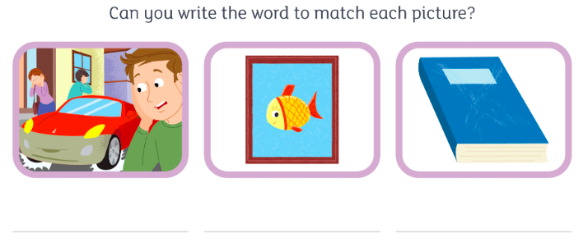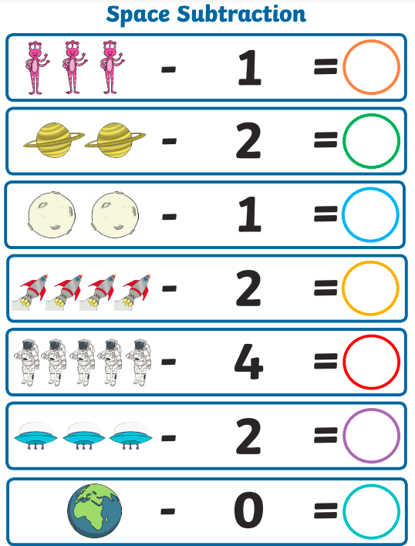

Thank you for your support

Parent signature: Miss Houghton

