
Please draw and describe the giant in Jack and The Beanstalk.
My Weekly Journal

_____________________________________________________________________________

Homework
Set Friday 26th April and due in by Wednesday 1st May.
Communication and language – Draw and describe the giant in Jack and The Beanstalk.
Literacy – Write the word to match the picture.
Maths – count and write the numbers to 20 with a focus on number formation please.

Please practice these CVCC words :
stop
trip
shower
lights
neck
frown
nettle
crumble

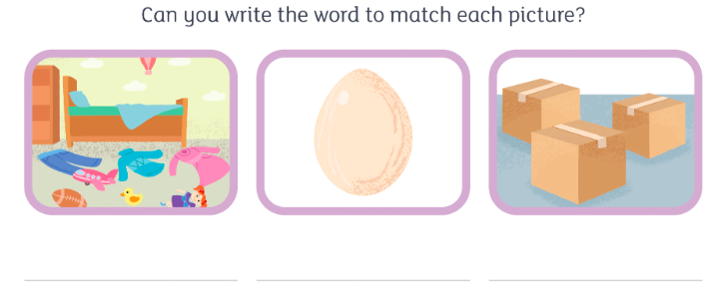

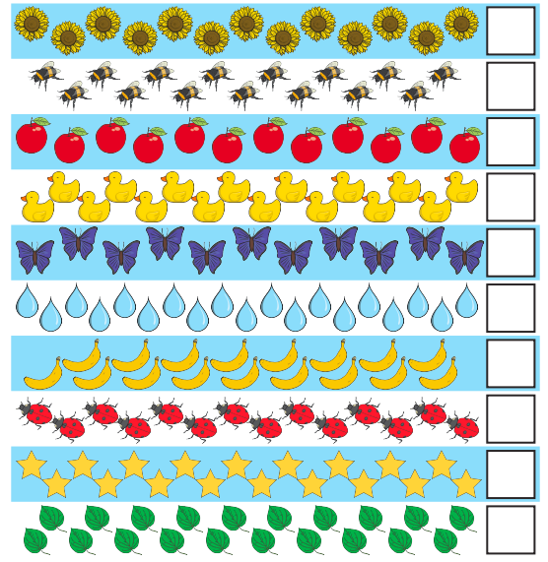

Thank you for your support

Parent signature: Miss Houghton

