
Please draw and write about the character Jack in Jack and The Beanstalk.
My Weekly Journal

_____________________________________________________________________________

Homework
Set Friday 19th April and due in by Wednesday 24th April .
Communication and language -Write a sentence and draw a picture about the character Jack in Jack and The Beanstalk.
Literacy – Write the word to match the picture.
Maths – Recognise and circle the 3-D shapes.

Please practice these CVCC words :
desk
sand
slip
clock
frogs
roast
toasted
mended

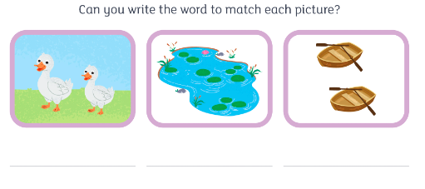

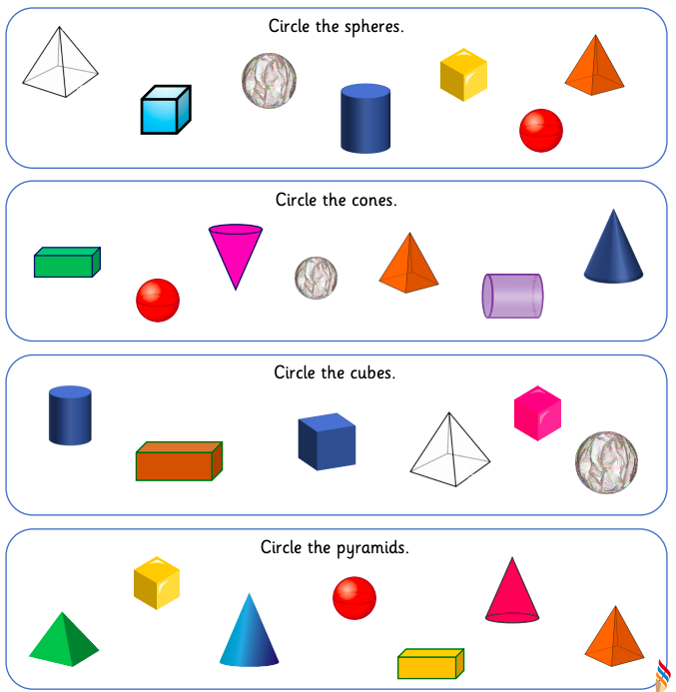

Thank you for your support

Parent signature: Miss Houghton

