
Please draw and write about Laurel Wood.
My Weekly Journal

_____________________________________________________________________________

Homework
Set Friday 15th March and due in by Wednesday 20th March.
Communication and language -Write a sentence and draw a picture about the tasks we took part in at Laurel Wood.
Maths homework – Please practice writing numbers 1-10 on the next page. A big push this week for numbers to be formed properly and the correct way round.

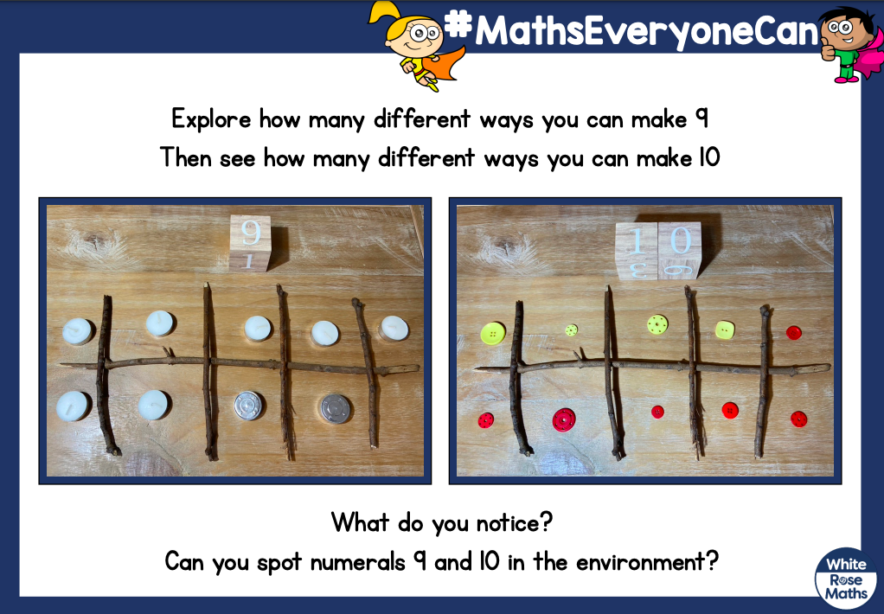

Please practice blending these words :
horse
night
class
habit
beam
spinning
purple
dinner

Harder to read and spell words this week: | little, one, do

Thank you for your support

Parent signature: Miss Houghton

