
Please draw and write about The Hungry Caterpillar.
My Weekly Journal

_____________________________________________________________________________

Homework
Set Friday 8th March and due in by Wednesday 13th March.
Communication and language -Write a sentence and draw a picture about The Hungry Caterpillar.
Maths homework – We have been focusing on length and height , have a go at the tasks below.

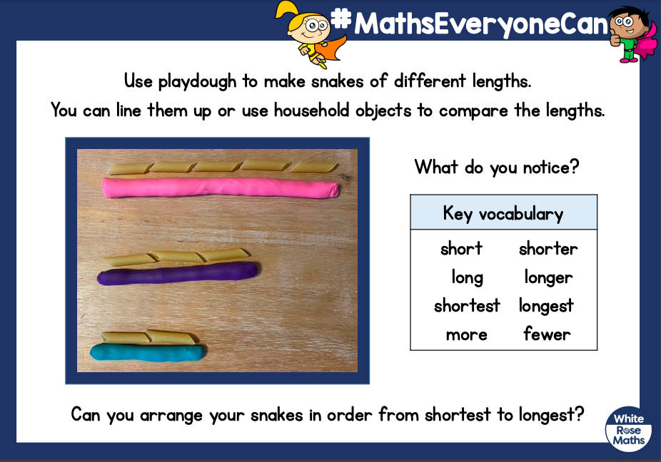

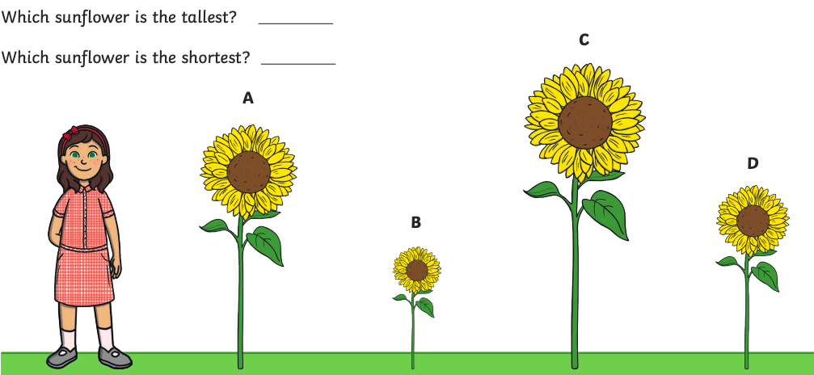

Please practice blending these words :
bell
crab
poor
claw
boss
glitch
sweeping
forest
Harder to read and spell words this week: | some, come, there

Important reminder – Wednesday 13th march 2024, Laurel Wood school trip. Please bring bags to school as normal. Please see separate letter attached for information on what your child should wear on the day.

Thank you for your support

Parent signature: Miss Houghton

