
Please draw and write about your weekend.
My Weekly Journal

_____________________________________________________________________________

Homework
Set Friday 1st March and due in by Wednesday 6th March.
Communication and language -Write a sentence and draw a picture about your weekend.
Maths homework – We have been focusing on number bonds to 10, have a go at the task on the next page.

Please practice blending these words :
wood
rain
swing
coin
bee
hair
blanket
Harder to read and spell words this week: | were, out, like, said, was , into , of

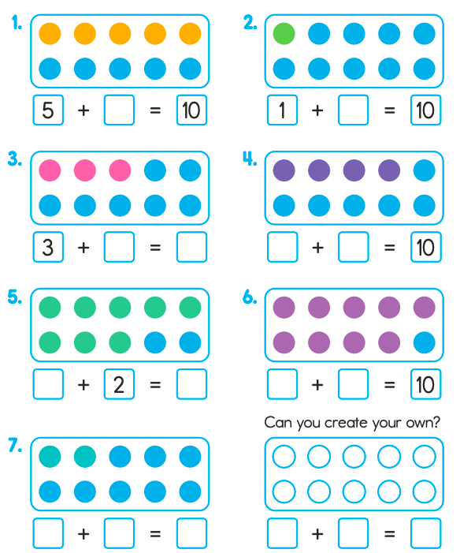

Thank you for your support

Parent signature: Miss Houghton

