
Please draw and write about your weekend.
My Weekly Journal

_____________________________________________________________________________

Homework
Set Friday 23rd February and due in by Wednesday 28th February.
Communication and language -Write a sentence and draw a picture about your weekend.
Maths homework – We have been focusing on numbers 6 7 and 8 this week, have a go at the task on the next page.

Understanding of the world: This half term our theme is Minibeasts. See if you can find any in your garden or at a the park. You can take a picture or sketch a picture using pencils.

Please practice blending these words :
park
wink
sheep
foam
now
locks
window
reading

Harder to read and spell words this week: | said, so , have

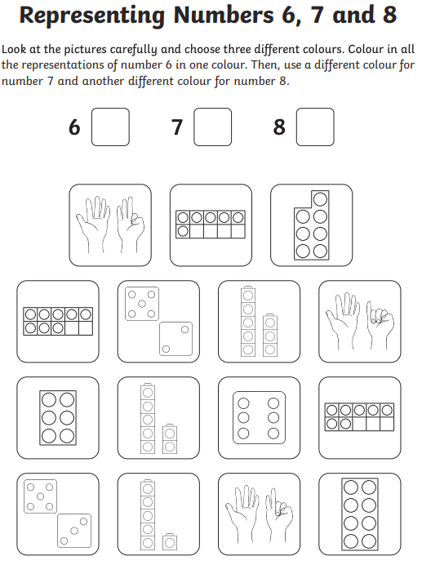

Thank you for your support

Parent signature: Miss Houghton

