
Please draw and write about your half term week.
My Weekly Journal

_____________________________________________________________________________

Homework
Set Friday 9th February and due in by Wednesday 21st February.
Communication and language -Write a sentence and draw a picture about your half term week.
Maths homework – We have been focusing on measurement this week. Have A go at the acitivty on the next page. If you wish you could bake a cake instead. Don’t forget to talk a photograph!

Understanding on the world: This half term our theme has been about ‘people who help us’. Create a poster about one job we have looked at explaining the importance of their role.

Please practice the sounds we have learnt this half term :
oo (pronounced as u e.g. book).
ar, ur, oo (pronounced ew e.g.moon) and or.
ow, oi, ear and air.
ure (pronounced ‘your’ for example sure, pure ), er and ow (pronounced ‘o’ for example crow, slow ).

Harder to read and spell words this week: | I The No Put Of Is To Go Into Pull As His He She We Me Be Push Was Her My You They All Are Ball Tall When What Said So

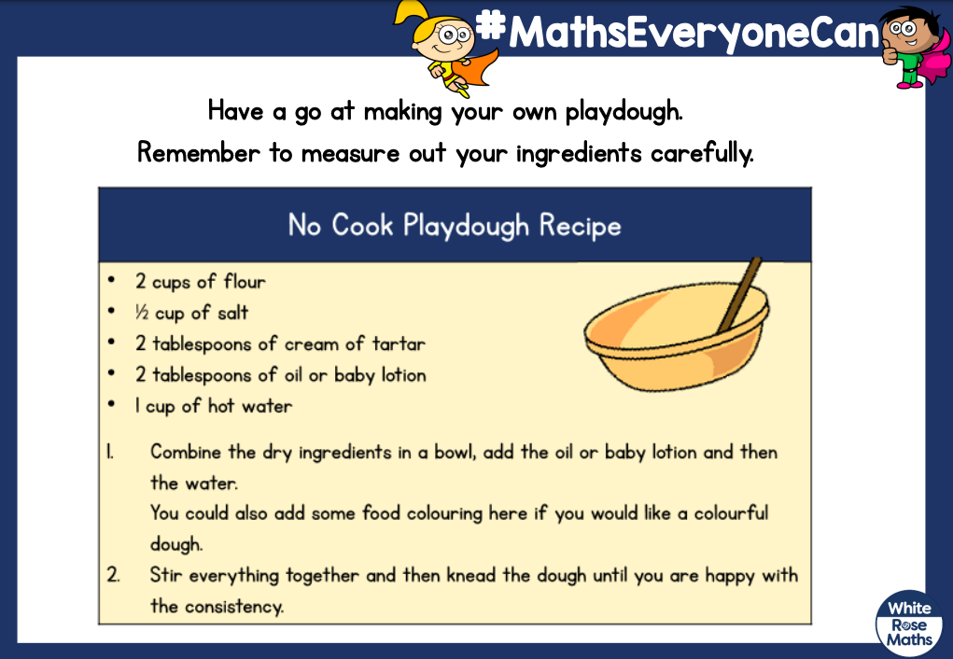

Important reminder – Parents evening Wednesday 21st February. Please ensure you book an appointment online. If you are unable to make this date please speak to me and book an appointment for another day.

Thank you for your support

Parent signature: Miss Houghton

