
Please draw and write about the role of a Postman.
My Weekly Journal

_____________________________________________________________________________

Homework
Set Friday 19th January and due in by Wednesday 24th January .
Communication and language -Write a sentence and draw a picture about the role of a Postman.
Maths homework – We have been representing numbers 0-5. Have a go at the task on the next page.

Art and Design : Our topic this week has been looking at the role of the Postman. Design a postage stamp for our Post Office. Get creative by using different materials and colours.

Please practice our sounds this week : ar, ur, oo (pronounced ew e.g.moon) and or.

Harder to read and spell words for this week: | I, The, No, Put, Of, My, You, They and All.

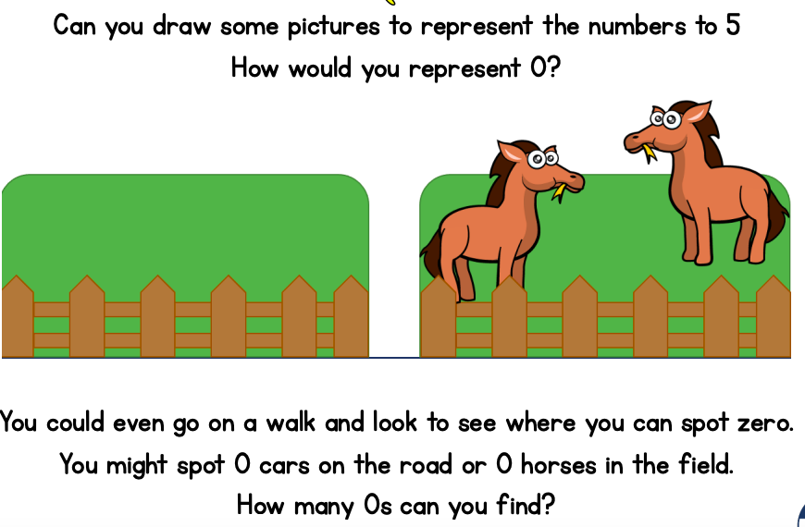

Thank you for your support

Parent signature: Miss Houghton

