
Please draw and write about you did during the Christmas Break.
My Weekly Journal

_____________________________________________________________________________

Homework
Set Friday 12th January and due in by Wednesday 17th January .
Communication and language -Write a sentence and draw a picture about the Christmas break.
Maths homework – We have been subitising numbers 1-5. Have a go at the activity on the next page.

Please practise these harder to read and spell words – I, the, no, put, of, is, to, go, into, pull, as, his, he, she, buses, we, me, be , was and her.
Please practice all sounds we have learnt so far and our new sound this week : ‘oo’. Pronounced u e.g. book, foot, wood.
Important reminders :
Please ensure you write a comment in reading records when hearing your child read a scheme reading book, not the library book.
Please ensure you put your child’s reading book in their bag on their reading day. This can be found on the front cover of the reading record.
Please ensure that you bring library books back every Wednesday to ensure we can change them. We are unable to change them on other days.

Count the fingers and colour the correct number

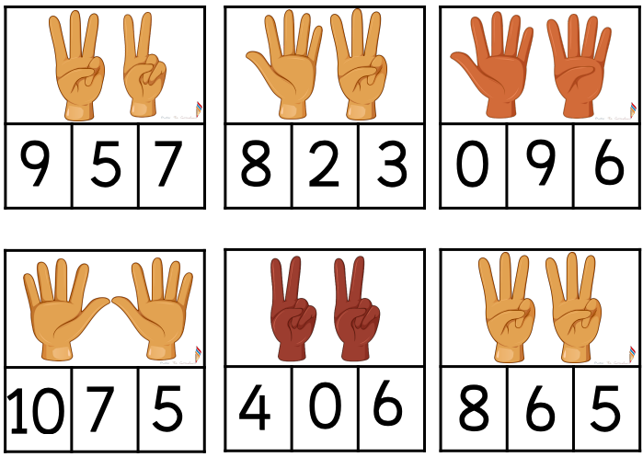

Thank you for your lovely Christmas gift & support in the Autumn term. We wish you & your family a fabulous 2024!
Love from,
Miss Houghton & Mrs Rimmer X

