
Please draw and write what you know about The Christmas Story.
My Weekly Journal

_____________________________________________________________________________

Homework
Set Friday 8th December and due in by Wednesday 13th December.
Communication and language -Write a sentence and draw a picture about The Christmas Story.
Maths homework – We have been learning about rectangles and triangles this week. Have a go independently at the task on the next page.

Please practise these harder to read and spell words – buses, we, me, be, push and was.
Please practice using your robot arms and blending hands – less, tent, wait, sweet, drink, clear and loan.

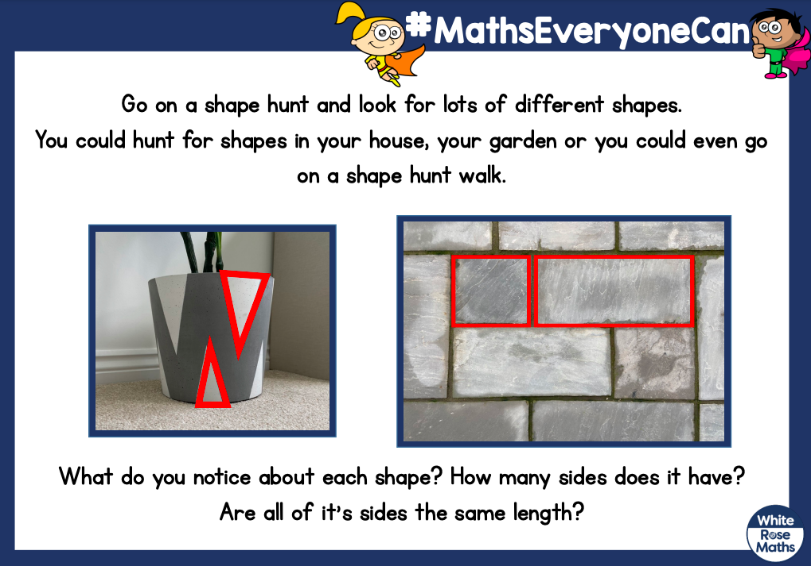

Thank you for your support

Parent signature: Miss Houghton

