
Please draw and write what you know about the Arctic.
My Weekly Journal

_____________________________________________________________________________

Homework
Set Friday 1st December and due in by Wednesday 6th December
Communication and language -Write a sentence and draw a picture about what you know about the Arctic.
Maths homework – We have been learning about different ways to make four and five this week. Complete the task on the next page.

Phonics sounds – Your child has taken part in a phonics assessment this week. We are fabulous at our sounds but we need some support with our harder to read and spell words and the use of our robot arms and blending hands.
Please practise these harder to read and spell words – Pull, as, his, he and she.
Please practice using your robot arms and blending hands – foam, high, box, meet and exit.

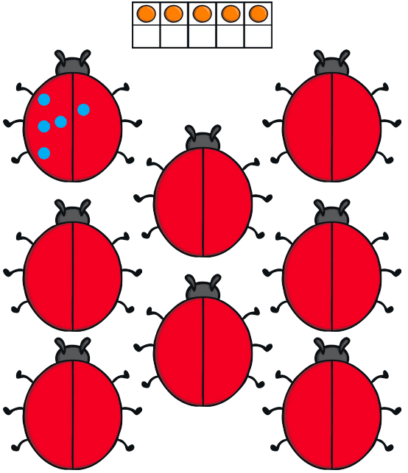

Thank you for your support

Parent signature: Miss Houghton

