
Please draw and write about our story this week ‘The Rainbow Fish’.
My Weekly Journal

_____________________________________________________________________________

Homework
Set Friday 24th November and due in by Wednesday 29th November
Communication and language -Write a sentence and draw a picture retelling The Rainbow Fish.
Maths homework – We have been learning about numbers 1 – 5 this week. Complete the task on the next page.

Phonics sounds – ai, ee , igh and oa. Please practise saying and writing the sounds. If you are unsure on how to say these sounds , please google ai, ee, igh and oa little wandle sound video.

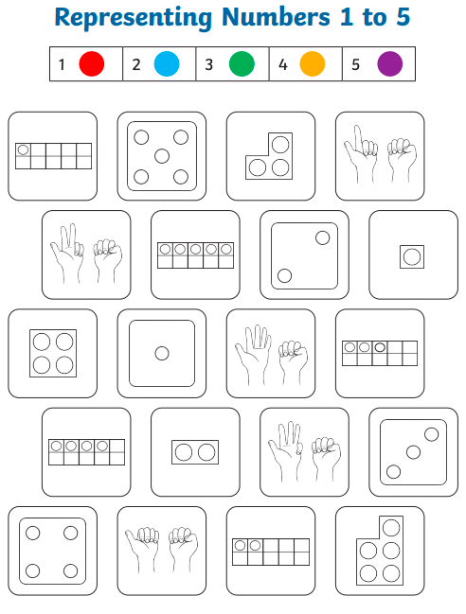

Thank you for your support

Parent signature: Miss Houghton

