
Please write a sentence and draw a picture retelling the Scarecrows’ Wedding.
My Weekly Journal

_____________________________________________________________________________

Homework
Set Friday 17th November and due in by Wednesday 22nd November
Communication and language -Write a sentence and draw a picture retelling the Scarecrows’ Wedding.
Maths homework – We have been learning about different positions this week, independently complete the activity on the next page!

Phonics sounds – sh, th, ng and nk. Please practise saying and writing the sounds.

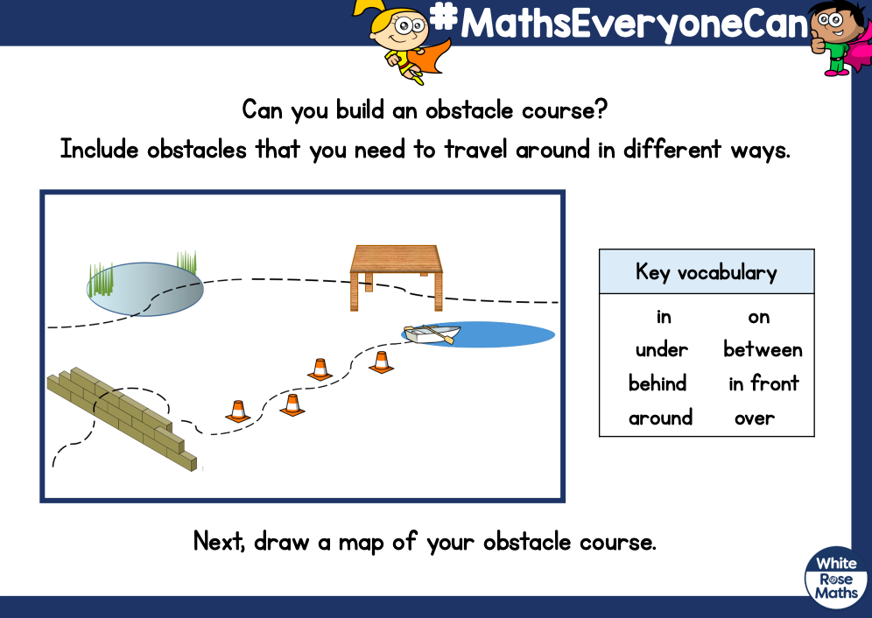

Thank you for your support

Parent signature: Miss Houghton

