
Please draw a picture and write a sentence about the weekend.
My Weekly Journal

_____________________________________________________________________________

Homework
Set Friday 10th November and due in by Wednesday 15th November
Communication and language -Draw a picture and write a sentence about your weekend.
Maths homework – We have been learning about circles and triangles this week, independently complete the activity on the next page!

Phonics sounds – y, z, qu and ch. Please practise saying and writing the sounds.

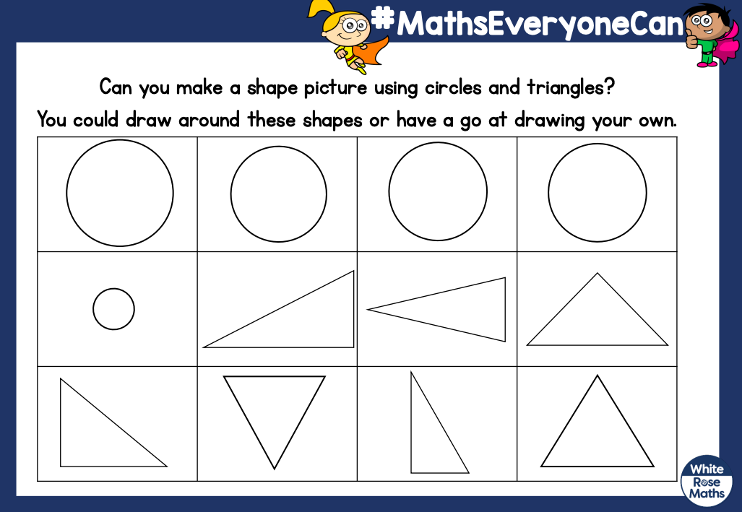

Here is an example to help you.



Thank you for your support

Parent signature: Miss Houghton

