
Please draw a picture and write a sentence about the weekend.
My Weekly Journal

_____________________________________________________________________________

Homework
Set Friday 3rd November and due in by Wednesday 8th November
Our new Christian Value for this term is PEACE.
Communication and language -Draw a picture and write a sentence about your weekend.
Maths homework – We have been learning about 1 more and 1 less than a number, independently complete the activity on the next page!

Phonics sounds – j, v , w and x. Please practise saying and writing the sounds.

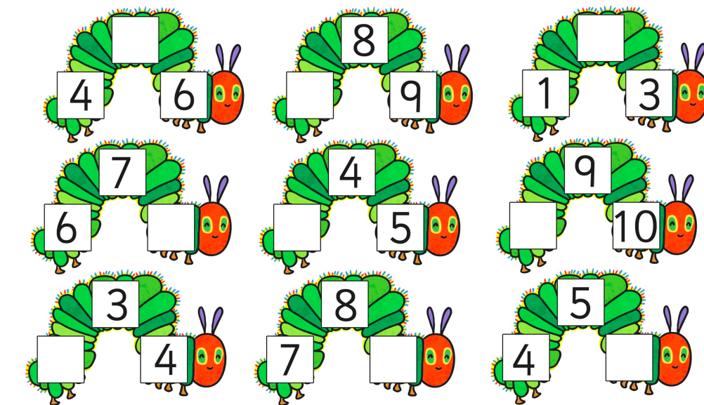

Thank you for your support

Parent signature: Miss Houghton

