
Please draw a picture and write a sentence about what you have been doing this half term.
My half term Journal

_____________________________________________________________________________

Homework
Set Friday 20th October and due in by Wednesday 1st November.
Communication and language -Draw a picture and write a sentence about your half term break.
Phonics sounds – Practice all the sounds we have learnt so far. Please see attached ELS sounds.
Mathematics – tracing over the numbers one to ten and then independently writing the numbers on the line.

Half term craft project : This week we have been reading the story ‘Owl Babies’ as part of our English lessons.
This half term I want you to create an owl baby to look after. Think about what the owl baby will need to keep warm and what it will need to eat and drink. Please get crafty when making your owl baby. Here are some examples of what your owl baby might look like.

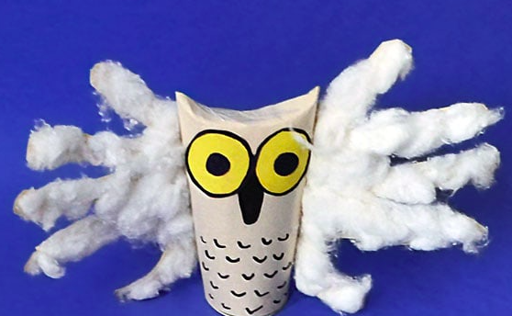
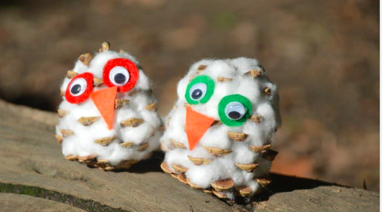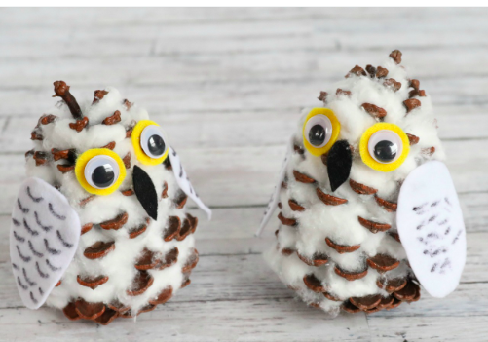

You may even want to go the extra mile and make a house for your owl baby!

Thank you for your support and have a lovely half term.

Parent signature: Miss Houghton

