
Please draw a picture and write a sentence about the weekend.
My Weekly Journal

_____________________________________________________________________________

Homework
Set Friday 13th October and due in by Wednesday 18th October.
Communication and language -Draw a picture and write a sentence about your weekend.
Phonics sounds – ss.
Please practice saying and writing the sound.

Maths homework – We have been learning about sequencing patterns this week. Have a go independently at the activity on the next page!

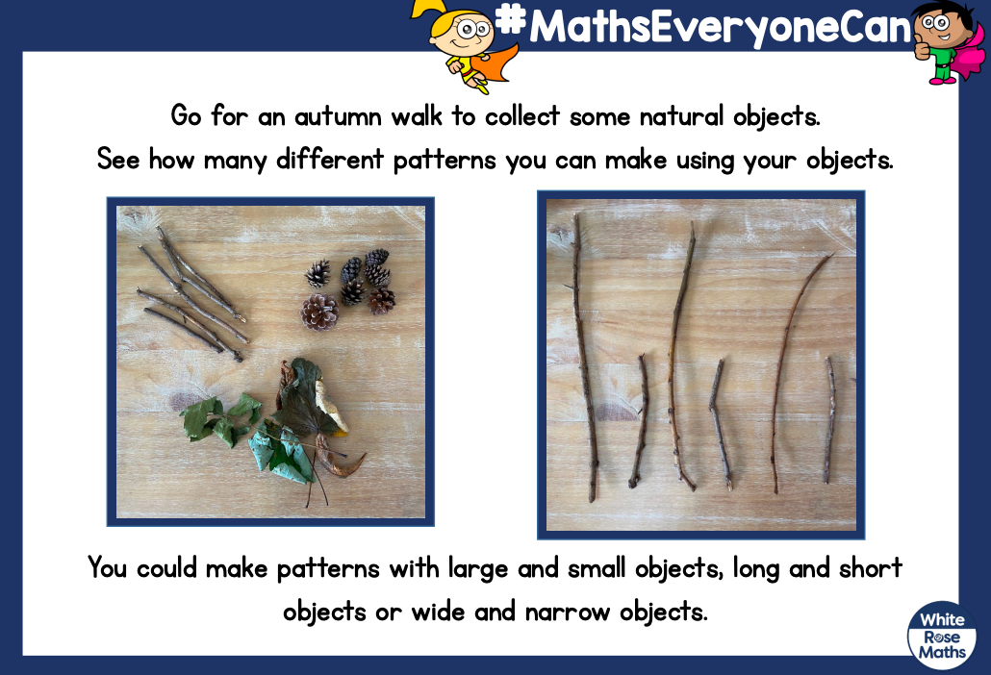

Thank you for your support

Parent signature: Miss Houghton

