
Please draw a picture and write a sentence about the weekend.
My Weekly Journal

_____________________________________________________________________________

Homework
Set Friday 6th October and due in by Wednesday 11th October.
Communication and language -Draw a picture and write a sentence about your weekend.
Phonics sounds – ck, e u and r. Please practice saying and writing the sounds.

Maths homework – We have been learning about mass and capacity this week. Have a go independently at the activity on the next page!

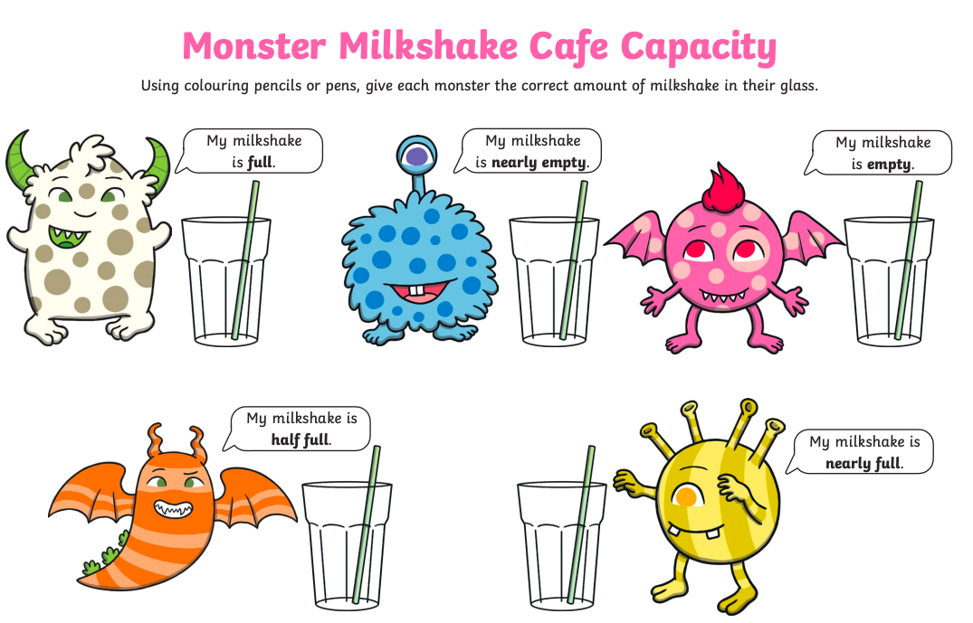

Thank you for your support

Parent signature: Miss Houghton

