
Please draw a picture and write a sentence about the weekend.
My Weekly Journal

_____________________________________________________________________________

Homework
Set Friday 29th September and due in by Wednesday 4th October
Communication and language -Draw a picture and write a sentence about your weekend.
Phonics sounds – g, o, c and k. Please practice saying and writing the sounds

Maths homework – We have been learning about sorting different sized objects and how they compare. Have a go at the activity on the next page!

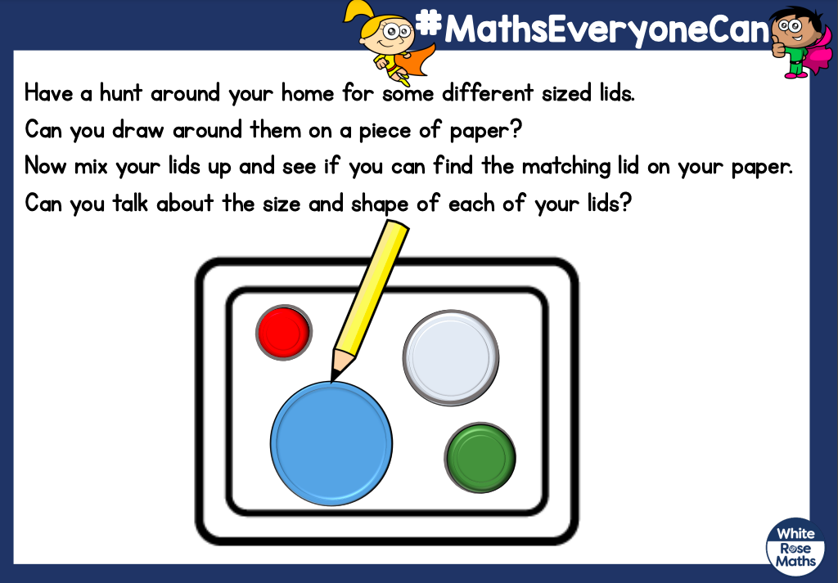

Thank you for your support

Parent signature:
Miss Houghton

