History home learning for Remembrance
Please choose from the topics below and hand to you class teacher by Friday November 3^{rd –} create a lovely eye catching poster about your topic OR choose from the other options below
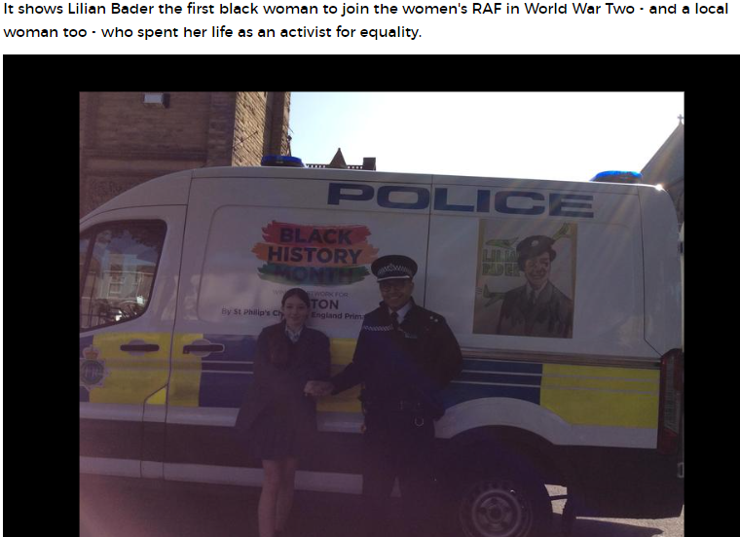
Have you seen our winning Black History Month Police Van celebrating Lilian Bader? You might like to watch this video and create your own poster about her – you can search for KS2 video Lilian Bader.
https://www.youtube.com/watch?v=6JfypN4ijDw
Or search for Walter Tull – he was on our winning police van last year – the BBC bitesize video Or
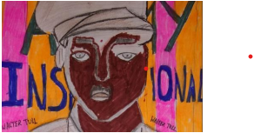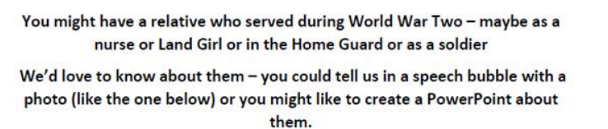
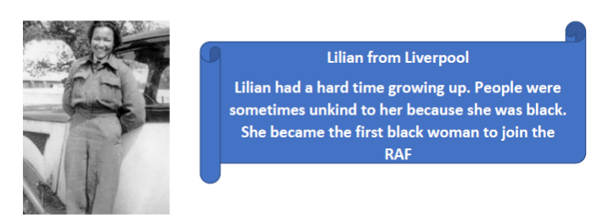
Or – visit our war memorial in town – it is one hundred years old this year – Princess Anne came this year to see it
Take a photo or your visit – look for any family names on it
History home learning for Remembrance
Please choose from the topics below and hand to you class teacher by Friday November 3^{rd –} create a lovely eye catching poster about your topic OR choose from the other options below
Have you seen our winning Black History Month Police Van celebrating Lilian Bader? You might like to watch this video and create your own poster about her – you can search for KS2 video Lilian Bader.
https://www.youtube.com/watch?v=6JfypN4ijDw
Or search for Walter Tull – he was on our winning police van last year – the BBC bitesize video Or
Or – visit our war memorial in town – it is one hundred years old this year – Princess Anne came this year to see it
Take a photo or your visit – look for any family names on it

