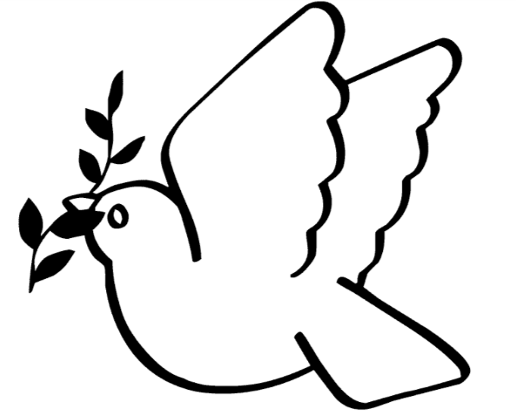
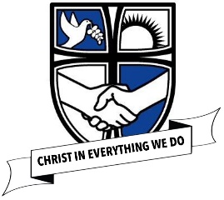
Christian values Autumn 2 ‘Peace’

This half term we would like you to decorate this dove for our new
Christian value ‘peace’.
If you would like you could also write a prayer on it. Please cut out your dove and hand into your teacher or class Worship Warriors. Remember to write your name and year on it please.
Thank you, Worship Warriors

Christian values Autumn 2 ‘Peace’

This half term we would like you to decorate this dove for our new
Christian value ‘peace’.
If you would like you could also write a prayer on it. Please cut out your dove and hand into your teacher or class Worship Warriors. Remember to write your name and year on it please.
Thank you, Worship Warriors

