
Christmas Homework
Year 6 - Due Jan 10th 2023

Homework Task – Below, you have 15 tasks that you can choose to complete over Christmas. For each task you complete, you will get points. The pupil with the most points will win a special prize however, each task that is completed, has to be signed off by an adult in the space below the task. You can use your pages in your homework book to complete the tasks but most importantly of all, relax, have fun and enjoy Christmas!
Love from the Year 6 team! 😊

  Watch a Christmas film  20 Points | 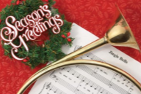  Sing a Christmas song  20 Points | 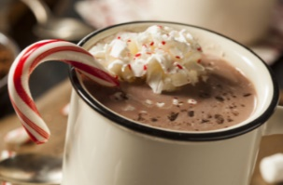  Have a hot chocolate  10 Points |   Go to the park  25 Points

  Write an acrostic poem for the word Christmas  30 Points | 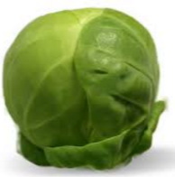  Eat a Brussel sprout  25 Points | 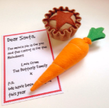  Leave presents out for Santa – Mince pie / Carrot  10 Points |   Play with a friend  20 Points
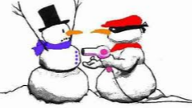  Tell a Christmas joke  10 Points |   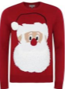  Go for a walk wearing a Christmas jumper or hat  40 Points |   Wish someone a ‘Merry Christmas’  30 Points |   Write a Christmas story including Santa and Rudolph  50 Points
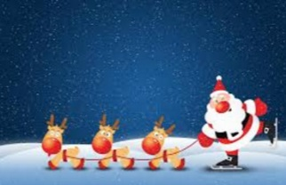  Draw a Christmas picture  30 Points | 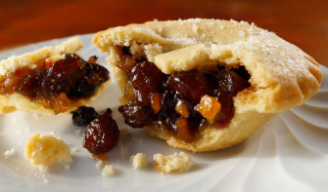  Eat a mince pie  15 Points | 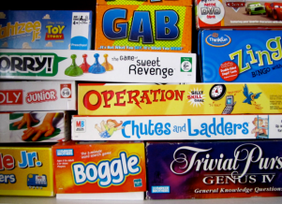  Play a board game  20 Points | Total Points Scored

