
Reading Challenges from the Reading Ambassadors!
The Reading Ambassadors would like you to pick one from the choices below to help us create our ‘Reading for Pleasure’ display board!
Please send all work in after half term by Friday 7th June. You can use a speech bubble if you choose a writing activity, or ask your teacher for plain paper for a drawing.
If you have a photograph or need to email your work, you can send it to Mrs Wright on wrightl@sps.sefton.school .
Thank you and have fun!
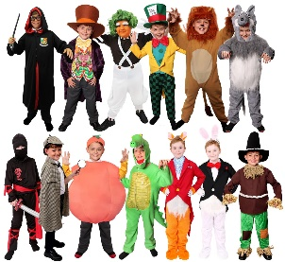  1.) Draw your favourite character/s from a book. Don’t forget to label them and tell us which book they are from! |   2.) Tell us who your favourite author is and why you like them. Could you find out some interesting facts about them?
  3.) Take a photo of you reading somewhere – maybe comfy and cosy at home, or at the library, or somewhere else! |   4.) Keep a list of EVERYTHING you read in one weekend – books, menus, street signs, shopping lists, magazines… How much do you read without even realising?
Reading Challenges from the Reading Ambassadors!
The Reading Ambassadors would like you to pick one from the choices below to help us create our ‘Reading for Pleasure’ display board!
Please send all work in after half term by Friday 7th June. You can use a speech bubble if you choose a writing activity, or ask your teacher for plain paper for a drawing.
If you have a photograph or need to email your work, you can send it to Mrs Wright on wrightl@sps.sefton.school .
Thank you and have fun!
1.) Draw your favourite character/s from a book. Don’t forget to label them and tell us which book they are from! | 2.) Tell us who your favourite author is and why you like them. Could you find out some interesting facts about them?
3.) Take a photo of you reading somewhere – maybe comfy and cosy at home, or at the library, or somewhere else! | 4.) Keep a list of EVERYTHING you read in one weekend – books, menus, street signs, shopping lists, magazines… How much do you read without even realising?

