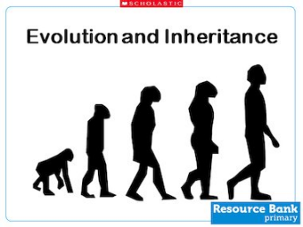
Choose ONE of the options below linked to our Science topic of ‘Evolution and Inheritance’ to complete.
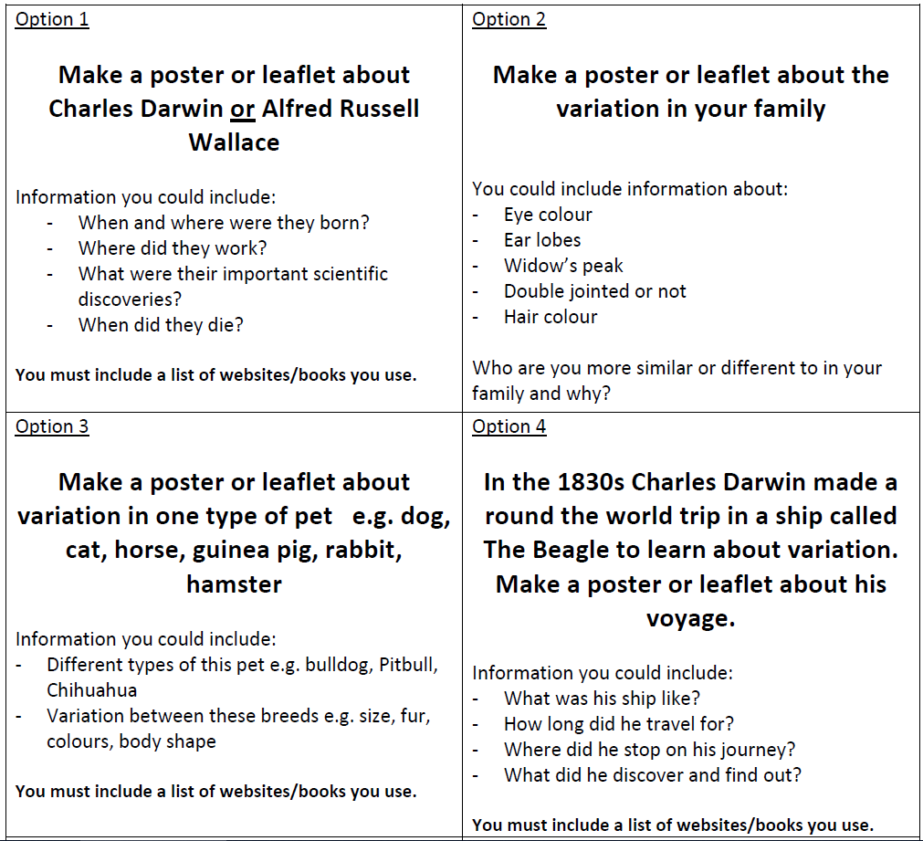
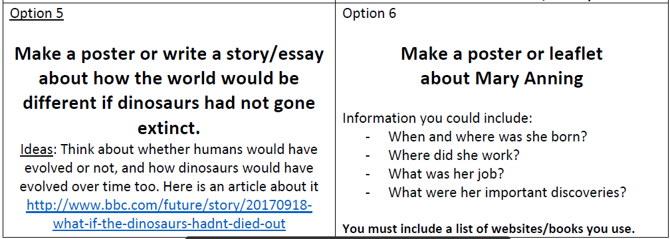
This can be in the form of a poster, leaflet, piece of writing or powerpoint presentation.

