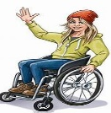
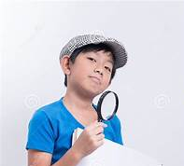
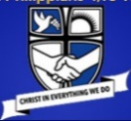
The Atkinson Prize Draw Selfie Challenge
February half term
Visit with a grown-up – open Mon to Sat 10am- 4pm
Be a history detective – look very carefully to learn from the exhibitions!
Sending your selfies means you give permission for them to be on display and on our website -Get your grown-up to email photos to me at the email address below
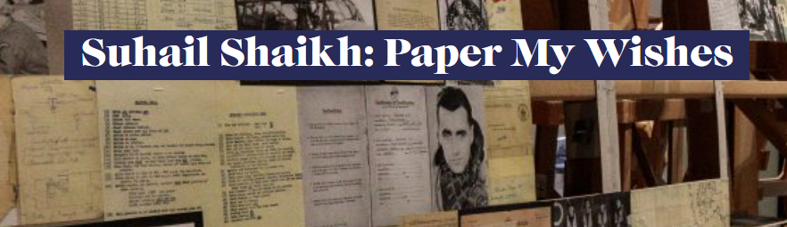
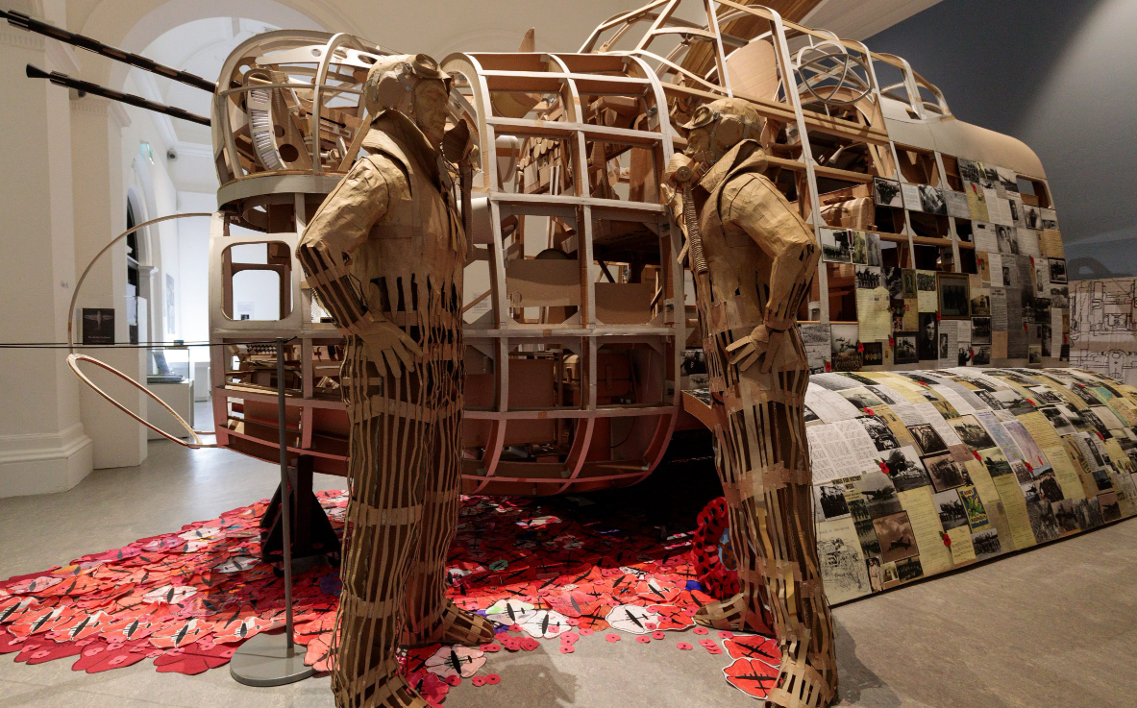
Enter the above exhibition through the art gallery – it is an amazing display of art using paper and cardboard. Take a selfie by the Lancaster Bomber display once you’ve had a good look at it and read about how the real planes were used and the local pilots who flew them.
Find who came to St Philip’s church – and what the mission to drop urgent food over The Netherlands was called – include these in your email for a chance to win the prize draw.
Other selfie opportunities upstairs in the museum -
- Try on the outfits – the glamour of the 1930s or the jobs
- Find the Mekon and take a selfie underneath it
- Pose at the sea bathing frame on your way out

Please email your selfies by Friday 23rd February 2024 to

The Atkinson Prize Draw Selfie Challenge
February half term
Visit with a grown-up – open Mon to Sat 10am- 4pm
Be a history detective – look very carefully to learn from the exhibitions!
Sending your selfies means you give permission for them to be on display and on our website -Get your grown-up to email photos to me at the email address below
Enter the above exhibition through the art gallery – it is an amazing display of art using paper and cardboard. Take a selfie by the Lancaster Bomber display once you’ve had a good look at it and read about how the real planes were used and the local pilots who flew them.
Find who came to St Philip’s church – and what the mission to drop urgent food over The Netherlands was called – include these in your email for a chance to win the prize draw.
Other selfie opportunities upstairs in the museum -
- Try on the outfits – the glamour of the 1930s or the jobs
- Find the Mekon and take a selfie underneath it
- Pose at the sea bathing frame on your way out

Please email your selfies by Friday 23rd February 2024 to

