Week Ending: 06.10.23
Homework due: Wednesday 11th October
This week…
Year 5 have had yet another great week in school. We filmed our own persuasive astronaut recruitment adverts, we had an amazing time problem solving with Mr Carter from Birkdale AND we were able to explore images taken from a telescope that had been blasted into space.

Next week…
- In maths we are going to be developing our mental strategies for addition and subtraction
- In English we are going to writing a letter of application to become an astronaut!
- Please ensure all uniform is labelled and that children bring their water bottles to school
- Harvest service in church Wednesday 9am 11th October – families welcome

At Home…
Reading:
It is so important that your child reads frequently throughout the week. At least 3 reading entries should be completed across the week, recording the book title and the pages read in the reading record book.

Spellings:
Please refer to the half termly overview for weekly spelling lists. This can also be found on the Year 5 class page on the school website.
You can also find a copy of Year 5 Spelling Passport words in this homework book, along with a ‘spelling menu’ of ideas on how to learn spellings at home.

Maths:
Please complete page 12 and 13 (Addition and Subtraction) in your Maths Practice Questions book.
Please continue to practise multiplication tables at home.
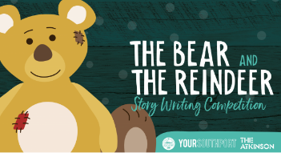
Optional Task:
Southport BID have launched 'The Bear and the Reindeer' story writing competition. The winning submission will be chosen as the official story of ‘The Bear and The Reindeer’ and will be displayed in Southport Library at The Atkinson over the festive period. The competition​ is being held to celebrate the arrival of 'The Bear and The Reindeer' illuminated figures which will be outside the Atkinson alongside the tree -pretty cool!

Follow this link for more information about this competition and how to enter. Please share with us any entries as we would love to read and celebrate them!
https://www.theatkinson.co.uk/2023/09/the-bear-and-the-reindeer/

