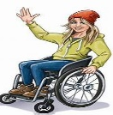
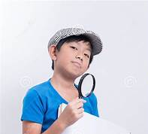
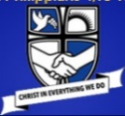
The Atkinson Prize Draw Selfie Challenge
February half term
Visit with a grown-up – open Mon to Sat 10am- 4pm
Be a history detective – look very carefully to learn from the exhibitions!
Sending your selfies means you give permission for them to be on display and on our website -Get your grown-up to email photos to me at the email address below
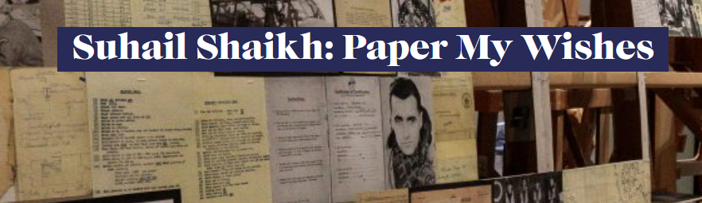
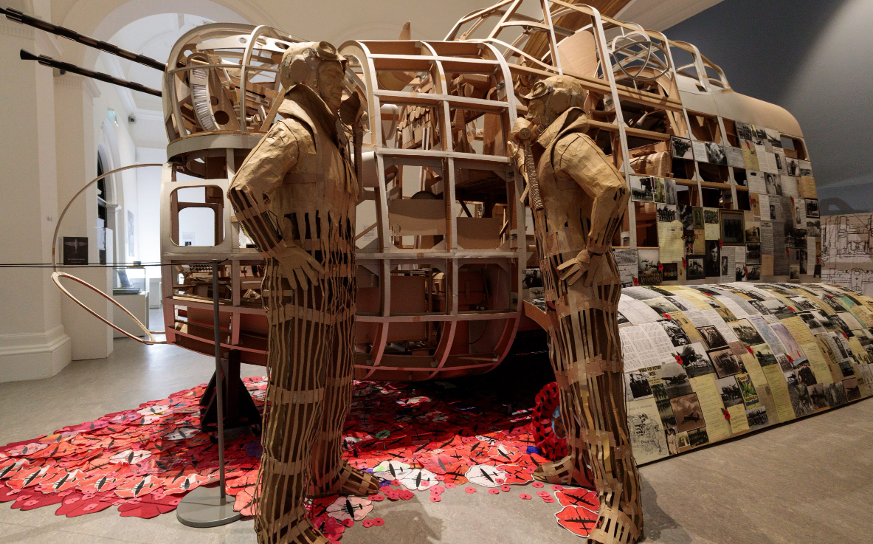
Enter the above exhibition through the art gallery – it is an amazing display of art using paper and cardboard. Take a selfie by the Lancaster Bomber display once you’ve had a good look at it and read about how the real planes were used and the local pilots who flew them.
Find who came to St Philip’s church – and what the mission to drop urgent food over The Netherlands was called – include these in your email for a chance to win the prize draw.
Other selfie opportunities upstairs in the museum -
- Try on the outfits – the glamour of the 1930s or the jobs
- Find the Mekon and take a selfie underneath it
- Pose at the sea bathing frame on your way out

Please email your selfies by Friday 23rd February 2024 to
Selfie-Comp@sps.sefton.school

