Week Ending: 28.1.25 Homework due: Wednesday 5th February 2025

Next week…
- Monday – Sweaty church + Homework ASC (invite only)
- Tuesday – Choir ASC
- Wednesday – Bart Gee visit + PE day
- Thursday – Trumpet Thursdays
- Friday – Number Day (£1 donation) –come into school as a number or with a number theme + PE day + football ASC
This week…
Another week has flown by in Year 4. Many fun learning opportunities as we near the half way point in the year. Photos are being added online of anything ‘cool’ we have been getting up to.
Many thanks,
Mr Vernon

.
At Home… Reading:
Adult’s score
3 entries in your reading record to claim your dojo!

Spellings
Please refer to the back of your homework books for spelling lists for Friday’s test.
List 4
Copy the word | Cover and spell | Copy again | Cover and test yourself

Maths:
Please log on to TTRS and complete 2 Soundchecks

English:
Please complete this advert for Sunshine Soap. You need to advertise it using AFOREST to persuade someone to buy it .
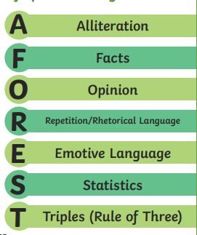


Parent/Carer comments:

Adult Signature: ………………………………….……

