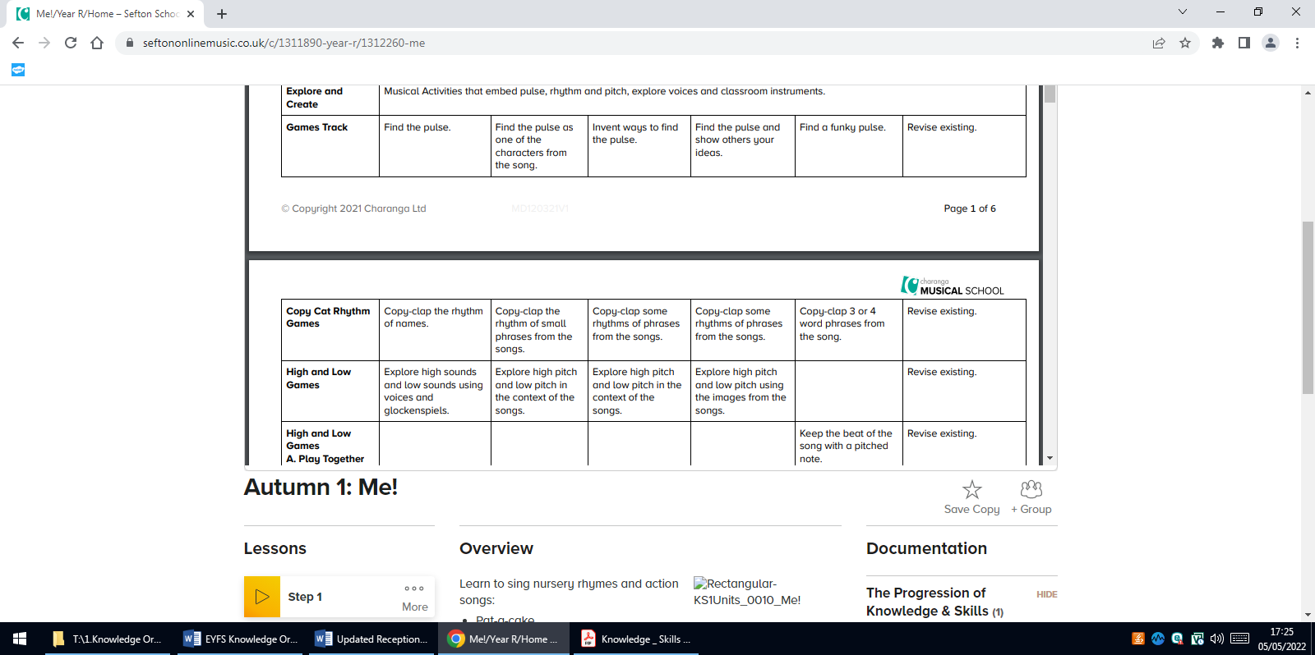
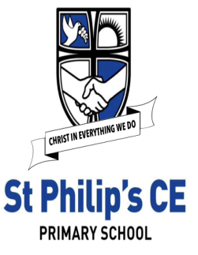
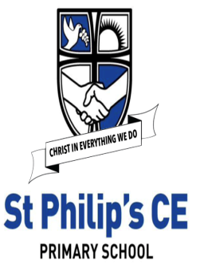
EYFS Expressive Arts and Design - Music
Knowledge Organiser
Supporting Songs and Styles
Autumn 1 - Me! by Joanna Mangona  Wide variety of musical styles as an introduction.  Celebration by Kool And the Gang  Happy by Pharell Williams  Sing by The Carpenters  Sing A Rainbow by Peggie Lee  Happy Birthday by Stevie Wonder  Our House by Madness | Autumn 2 - My Stories by Joanna Mangona  Wide variety of musical styles as an introduction.  Roll Alabama by Bellowhead  Boogie Wonderland by Earth Wind and Fire  Don’t Go Breaking My Heart by Elton John and Kiki Dee  Ganesh Is Fresh by MC Yogi  Frosty the Snowman sung by Ella Fitzgerald  Spiderman sung by Michael Bublé
Spring 1 - Everyone! by Joanna Mangona  Wide variety of musical styles as an introduction.  We Are Family by Sister Sledge  Thula Baba by Hlabalela Ensemble  ABC by The Jackson 5  My Mum Is Amazing (feat. Zain Bhikha) by Zimtech Productions  Conga by Miami Sound Machine  Horn Concerto No 4: Third Movement – Rondo by Mozart | Spring 2 - Our World by Joanna Mangona  Wide variety of musical styles as an introduction.  Lovely Day by Bill Withers  Beyond the Sea sung by Robbie Williams Mars from The Planets Suite by Gustav Holst  Frog’s Legs and Dragon's Teeth by Bellowhead  Ain’t No Mountain High Enough sung by Marvin Gaye and Tammi Terral  Singing in The Rain performed by Gene Kelly
Summer 1 - Big Bear Funk by Joanna Mangona  Funk  Big Bear Funk by Joanna Mangona  I Feel Good by James Brown  Don’t You Worry ‘Bout a Thing sung by Incognito  My Promise by Earth Wind and Fire  Superstition by Stevie Wonder  Pick Up the Pieces by Average White Band | Summer 2 - Reflect, Rewind and Replay  Classical  William Tell Overture by Rossini  Dance of The Sugar Plum Fairy by Tchaikovsky  Flight of The Bumblebee by Rimsky-Korsakov  Jupiter, The Bringer of Jollity by Gustav Holst  Fantasia on A Theme by Thomas Tallis by Ralph Vaughan Williams  E.T. Flying Theme by John Williams
Listen and Respond
Knowledge | Skills
● To know twenty nursery rhymes off by heart.  ● To know the stories of some of the nursery rhymes. | ● To learn that music can touch your feelings.  ● To enjoy moving to music by dancing, marching, being animals or Pop stars
Explore and Create (Musical Activities)
Knowledge | Skills
● To know that we can move with the pulse of the music.  ● To know that the words of songs can tell stories and paint pictures. | There are progressive Music Activities within each unit that embed pulse, rhythm and pitch. Children listen to and work with the Games Track to complete the following in relation to the main song:  ● Activity A Games Track Find the pulse by copying a character in a nursery rhyme, imagining a similar character or object and finding different ways to keep the pulse.  ● Activity B Copycat Rhythm Copy basic rhythm patterns of single words, building to short phrases from the song/s.  ● Activity C High and Low Explore high and low using voices and sounds of characters in the songs. Listen to high-pitched and low-pitched sounds on a glockenspiel.  ● Activity D Create Your Own Sounds Invent a pattern using one pitched note, keep the pulse throughout with a single note and begin to create simple 2-note patterns to accompany the song.  ● Extension Activity Adding a 2-note melody to the rhythm of the words. Playing with two pitched notes to invent musical patterns.
Singing
Knowledge | Skills
● To sing or rap nursery rhymes and simple songs from memory.  ● Songs have sections. | ● To sing along with a pre-recorded song and add actions.  ● To sing along with the backing track.
Share and Perform
Knowledge | Skills
● A performance is sharing music. | ● Perform any of the nursery rhymes by singing and adding actions or dance.  ● Perform any nursery rhymes or songs adding a simple instrumental part.  ● Record the performance to talk about.
Musical Themes | Key Vocabulary
Pulse | pulse - a steady beat like a ticking clock or your heartbeat. It can be measured in time by counting the number of beats per minute (BPM).
Rhythm patterns
High and low sounds | rhythm - the pattern of long and short sounds as you move through the song.
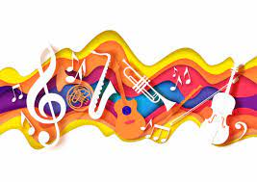 | pitch - is how high or low a note sounds. A melody is made up of high- and low-pitched notes played one after the other.
 | high sounds - high frequency of vibration of the sound waves producing them.
 | low sounds - low frequency of vibration of the sound waves producing them.
 | perform - presenting a song or piece to an audience.
 | unison - two or more musical parts sounding the same pitch or at an octave interval.
 | phrase - a section of music that makes sense on its own.

