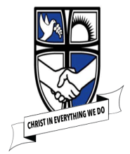
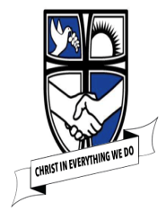
EYFS Understanding the World – Threads of History
Knowledge Organiser
  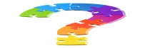  Links to Development Matters | Early Reading Linked to Key Texts
Reception:  - Begin to make sense of their own life-story and family’s history.  - Comment on images of familiar situations in the past.  - Compare and contrast characters from stories including figures from the past. | Autumn 1  Jake’s First Day  Marvellous Me  Monkey Puzzle  Leafman  Handa’s Surprise  Non – Fiction based around families, human bodies, growing. | Autumn 2  The Scarecrow’s Wedding  The Runaway Iceberg  The Polar Express  The Christmas Story
Early Learning Goals
Past and Present  - Talk about the lives of people around them and their roles in society.  - Know some similarities and differences between things in the past and now, drawing on their experiences and what has been read in class.  - Understand the past through settings, characters and events encountered in books read in class and storytelling.  People, Culture and Communities  - Describe their immediate environment using knowledge from observations, discussions, stories, non-fiction texts and maps.  - Know some similarities and differences between families, different religious and cultural communities, cultures and traditions. | Spring 1  The Jolly Postman  Cops and Robbers  Fireman Sam  Topsy and Tim | Spring 2  Mad about Minibeasts  The Very Hungry Caterpillar  Snail Trail  The Tiny Seed
 | Summer 1  Jack and the Beanstalk  The Gingerbread Man  The Three Little Pigs | Summer 2  Sharing a Shell  Tiddler  The Whale’s Song  The Seal Surfer  The Dolphin Boy  Lighthouse Keepers lunch
  Concepts | 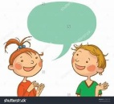  Key vocabulary
I know about my family and where I was born. | family, surname, auntie, uncle, brother, sister, cousin, grandparents, niece, nephew, Southport, England, UK
I know that as I get older I can do different things. | change, different, same, yesterday, today, tomorrow, grow
I know that my Grandparents are my Mum and Dads parents. | family, grandparents, grandchild
I know that things have changed since my Mum and Dad were little. | change, different, same
I know which objects are from the past and which are modern (toys, home artefacts, transport) | new, old, past, present, travel, steam train, electric train
I know some facts about people from the past. | Guy Fawkes, Florence Nightingale, Bonfire Night, plot, lamp, parliament
I know that some stories have been around for a long time and that some are new. | traditional tales, author, illustrator, changed, adapted
I know that families celebrate in different ways. | tradition, meal, party, celebration, invitation
I know some celebrations / festivals and can say why they are celebrated. | Christian, Christmas, Easter, Bonfire Night, Diwali, Chinese New Year, Jesus, Disciples, Hinduism, Rama, Sita, Lunar Calendar
How this is achieved in EYFS at St Philip’s
Autumn Term:  All about me:  - Discussing our families, recounting fun family experiences in our past.  - Thinking about changes in our life as we grow and get older.  - Look at how homes have changed over time. Compare own homes to those from the past.  Polar Explorers:  - Exploring and comparing steam train and electric trains  Festivals:  - Explore festivals and family traditions from different cultures inc: Christmas, bonfire night, Halloween, Diwali, Harvest Festival, Remembrance Day and Christingle.  Spring Term:  People who help us:  - Find out about people who help us and how jobs and places of work have changed.  Minibeasts:  - Observing life cycles and seeing how animals grow and change over time.  Spring Festivals  - Explore festivals and family traditions from different cultures inc: Easter  - Exploring family traditions of Shrove Tuesday  - Explore the festival and family traditions of Chinese New Year | Summer Term:  Traditional Tales:  - Look at traditional tales and notice how they have been adapted and changed over time.  Around the world:  - Recount and share family experiences of holidays abroad  - Talk about how holidays have changed over time.  - Recount and share family experiences of holidays in the UK.  - Look at a Victorian holiday.  - Compare modes of travel on the sea.  General learning throughout the year:  - Through interactions talking about what they did yesterday, last week, last year.  - Personal history; how they celebrate Christmas, new year, family celebrations such as Birthday’s – throughout the year.  Learning about the family traditions of children in class from different cultural backgrounds.  Curriculum links and further research  Christian values – thankfulness, caring, loving  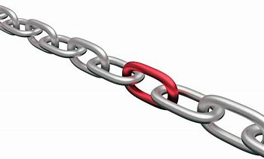  - Art/DT – Self-portaits  - Geography, Science – To explore the natural world around them, describing what they see, hear and feel whilst outside;  - To observe the effect of changing seasons on the natural world around them;  Enrichment Opportunities  - Role play areas – Fruit and veg shop, home corner.  - Reading area – all about me books, non-fiction body parts, explorers, people who help us, life cycles.  - Children will explore their classroom, school and school grounds and know who key people are in school.

