
Please draw and write what you know about The Gingerbread Man.
My Weekly Journal

_____________________________________________________________________________

Homework
Set Friday 9th May and due in by Tuesday 13th May.
Communication and language – Draw and write about The Gingerbread Man.
Literacy – Write the word to match the picture.
Maths – simple addition worksheet.

Please practice these CVCC words :
still
dusk
grand
storm
knock
glitter
crushed
settled

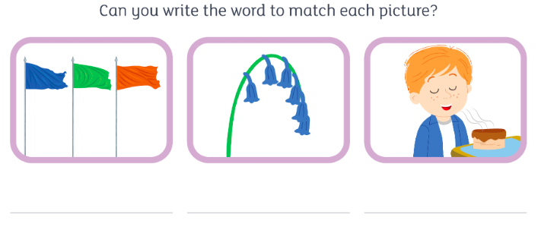

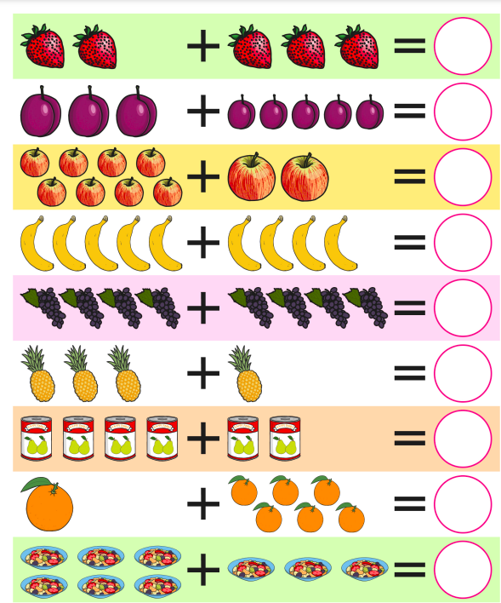

Thank you for your support

Parent signature: Miss Houghton

