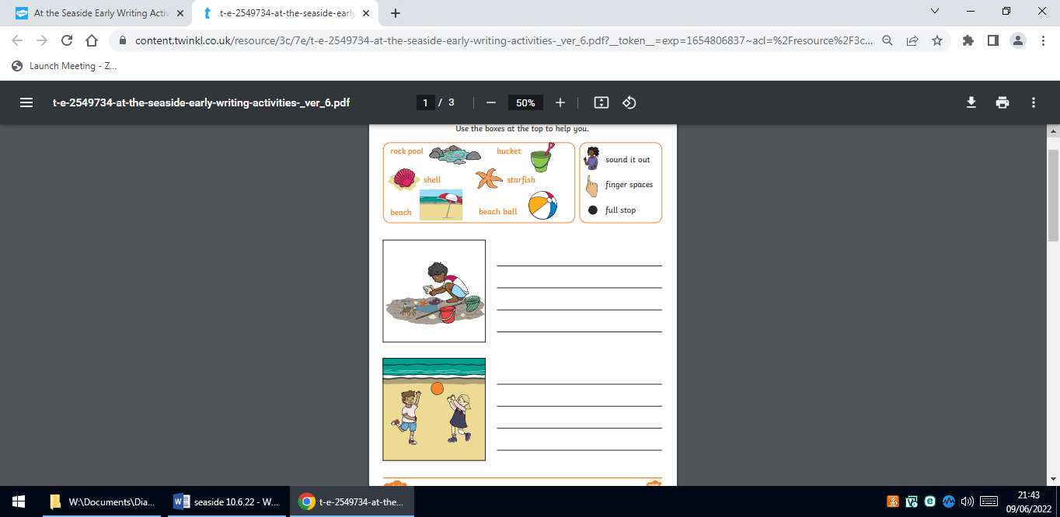
Homework
Please write a sentence about each picture?

