Homework
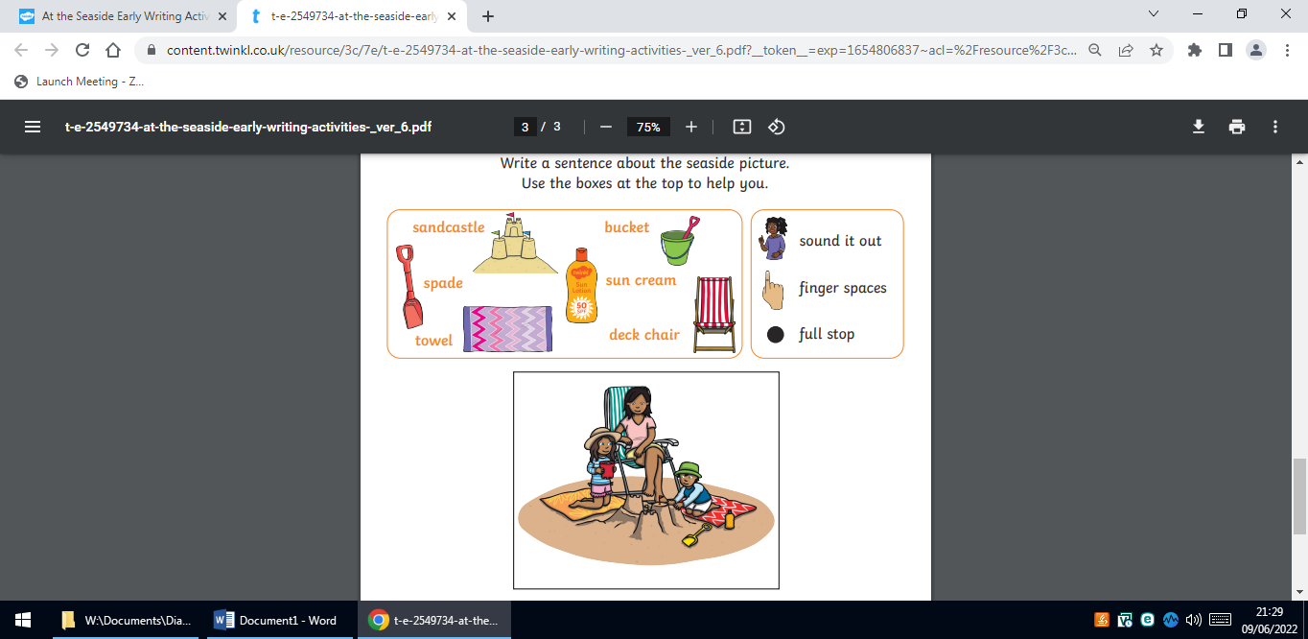
Please write a paragraph about what is happening in the picture?

Homework
Please write a paragraph about what is happening in the picture?

